

Consulting Services for
Support to Water Resources Management in the
Drina River Basin
Project ID No. 1099991

serbia- Investment prioritisation framework report
volume 2 – annexes

April 2017



Consulting Services for
Support to Water Resources Management in the
Drina River Basin
Project ID No. 1099991

serbia – Investment prioritisation framework report
volume 2 – annexes

April 2017

Project No. A038803
Document no. 1
Version B
Date of issue April 2017
Prepared JV COWI-Stucky-JCI team as in Inception Report
Checked Nadja Zeleznik, REC
Approved Roar Selmer Solland, COWI

Table of Contents
Page No

Acronyms and Abbreviations x
1 Annex 1 – Supporting Inventory of Changes for DRB development Chapter 3 1-1
1.1 Annex 1-1: Supporting IPF report Sub-chapter 3-3 Financing and its influence on priorities 1-1
1.2 Annex 1-2: Supporting IPF Report Sub-chapter 3.12 Analysis of Environmental and Social Impact of investments 1-6
2 Annex 2 – Supporting Water management development options Chapter 2-20
2.1 Annex 2-1: Supporting IPF Report Sub-chapter 4-4 Monitoring 2-20
3 Annex 3 – Supporting Modelling the impacts of development options on Water balance Chapter 3-21
3.1 Annex 3-1 Supporting Sub-chapter 5-2 Influence of climate change on hydrology 3-21
3.2 Annex 5-2 Supporting Sub-chapter 5-3 Water resources system modelling 3-44
3.3 Annex 3-3 Supporting Sub-chapter 5.4 Flood risk assessment 3-1
4 Annex 4 – Supporting Multi-criteria analysis of development scenarios Chapter 4-5
4.1 Annex 4-1 Economic costs and benefits per scenarios 4-5
4.2 Annex 4-2 Sensitivity analysis 4-6
5 Annex 5 – Comments and responds 5-1

List of Figures
Page No
Figure 5-1: Long-term mean annual (ANN) and mean seasonal projections for analyzed hydrologic stations in accordance with the CM1 climate parameter seta – Part 1 5-24
Figure 5-2: Long-term mean annual (ANN) and mean seasonal projections for analyzed hydrologic stations in accordance with the CM1 climate parameters set – Part 2 5-25
Figure 5-3: Long-term mean annual (ANN) and mean seasonal projections for analyzed hydrologic stations in accordance with the climate CM2 parameter set – Part 1 5-26
Figure 5-4: Long-term mean annual (ANN) and mean seasonal projections for analyzed hydrologic stations in accordance with the CM2 climate parameter set – Part 2 5-27
Figure 5-5: Long-term mean annual (ANN) and mean seasonal projections for analyzed hydrologic stations in accordance with the CM3 climate parameter set – Part 1 5-28
Figure 5-6: Long-term mean annual (ANN) and mean seasonal projections for analyzed hydrologic stations in accordance with the CM3 climate parameter set – Part 2 5-29
Figure 5-7: Long-term mean annual (ANN) and mean seasonal projections for analyzed hydrologic stations in accordance with the CM4 climate parameter set – Part 1 5-30
Figure 5-8: Long-term mean annual (ANN) and mean seasonal projections for analyzed hydrologic stations in accordance with the CM4 climate parameter set – Part 2 5-31
Figure 5-9: Long-term mean annual (ANN) and mean seasonal projections for analyzed hydrologic stations in accordance with the CM5 climate parameter set – Part 1 5-32
Figure 5-10: Long-term mean annual (ANN) and mean seasonal projections for analyzed hydrologic stations in accordance with the CM5 climate parameter set – Part 2 5-33
Figure 5-11: Long-term mean annual (ANN) and mean seasonal projections for analyzed hydrologic stations in accordance with the CM6 climate parameter set – Part 1 5-34
Figure 5-12: Long-term mean annual (ANN) and mean seasonal projections for analyzed hydrologic stations in accordance with the CM6 climate parameter set – Part 2 5-35
Figure 5-13: Long-term mean annual (ANN) and mean seasonal projections for analyzed hydrologic stations in accordance with the CM7 climate parameter set – Part 1 5-36
Figure 5-14: Long-term mean annual (ANN) and mean seasonal projections for analyzed hydrologic stations in accordance with the CM7 climate parameter set – Part 2 5-37
Figure 5-15: Long-term mean annual (ANN) and mean seasonal projections for analyzed hydrologic stations in accordance with the CM8 climate parameter set – Part 1 5-38
Figure 5-16: Long-term mean annual (ANN) and mean seasonal projections for analyzed hydrologic stations according to the CM8 climate parameter set – Part 2 5-39
Figure 5-17: Relative changes (Δ) of mean annual discharges (ANN) during the periods of near (from 2011 to 2040) and distant future (from 2041 to 2070) for analyzed hydrologic stations and used climate data sets (CM1 to CM8). 5-40
Figure 5-18: Relative changes (Δ) of mean proticaja in the course of winter season (DJF) during the periods of near (from 2011 to 2040) and distant future (from 2041 to 2070) for analyzed hydrologic stations and used climate data sets (CM1 to CM8). 5-41
Figure 5-19: Relative changes (Δ) of mean discharges in the course of spring season (MAM) during the periods of near (from 2011 to 2040) and distant future (from 2041 to 2070) for analyzed hydrologic stations and used climate data sets (CM1 to CM8). 5-42
Figure 5-20: Relative changes (Δ) of mean discharges in the course of summer season (JJA) during the periods of near (from 2011 to 2040) and distant future (from 2041 to 2070) for analyzed hydrologic stations and used climate data sets (CM1 to CM8). 5-43
Figure 5-21: Relative changes (Δ) of mean proticaja in the course of autumn season (SON) during the periods of near (from 2011 to 2040) and distant future (from 2041 to 2070) for analyzed hydrologic stations and used climate data sets (CM1 to CM8). 5-44
Figure 5-22: Relative changes (Δ) of higher mean annual proticaja with exceedance probability of 10% during the periods of near (from 2011 to 2040) and distant future (from 2041 to 2070) for analyzed hydrologic stations and used climate data sets (CM1 to CM8). 5-45
Figure 5-23: Relative changes (Δ) of lower mean annual discharges with exceedance probability of 90% during the periods of near (from 2011 to 2040) and distant future (from 2041 to 2070) for analyzed hydrologic stations and used climate data sets (CM1 to CM8). 5-46
Figure 5-24 Planned HPPs :in red the values proposed for an harmonized EF over the DRB (- no data) 5-1
Figure 5-25. Flood frequency distribution of floods at Radalj for the baseline period compared to the distribution obtained from the complete record. 5-1
Figure 5-26. Flood frequency distributions for baseline period and two future periods under two climate scenarios (left graphs: RCP 4.5, right graphs: RCP 8.5). 5-2

List of Tables
Page No

Table 3-1: HPP Investment Costs (EUR, Constant 2016 prices) 3-5
Table 3-2: HPP Operation Costs Scenario 2 (EUR, Constant 2016 prices) 3-6
Table 3-3: HPP Operation Costs Scenario 3 (EUR, Constant 2016 prices) 3-7
Table 3-4: Environment - Without mitigation measures – Construction phase 3-8
Table 3-5: Social - Without mitigation measures – Construction phase 3-12
Table 3-6: Environment - Without mitigation measures – Operation phase 3-15
Table 3-7: Social - Without mitigation measures –Operation phase 3-19
Table 4-1: Proposed new meteorological stations u slivovima reka Rzav, Beli i Crni Rzav i Žepa 4-23
Table 4-2: Proposed new meteorological stations in Rogačica River, Trešnjica River, Ljuboviđa River and Drinjača River basins 4-23
Table 5-1 Existing HPPs 5-47
Table 5-2. 100-year flood flows of Drina at Radalj hydrologic station – comparison of estimates based on the observed and simulated hydrology. 5-3
Table 6-1: Economic costs and benefits Scenario 2 (EUR, Constant 2016 prices) 6-5
Table 6-2: Economic costs and benefits Scenario 3 (EUR, Constant 2016 prices) 6-5
Table 6-3 Scenario 2 6-6
Table 6-4 Scenario 3 6-7

ACRONYMS AND ABBREVIATIONS
BiH | Bosnia and Herzegovina
ºC | Degrees Celsius
CG | Crna Gora (Montenegro)
DRB | Drina River Basin
EBRD | European Bank for Reconstruction and Development
EEA | European Environmental Agency
EF | Environmental Flow
EIA | Environmental Impact Assessment
EP | Elektroprivreda
EPA | Environmental Protection Agency
EPCG | Elektroprivreda Crna Gore (Montenegro)
EPR | Environmental Performance Review
EPS | Elektroprivreda Serbia
ERS | Elektroprivreda Republike Srpske
EU | European Union
EUR | Euro
FBiH | Federation of Bosnia and Herzegovina
FCDA | Federal Civil Defence Authority
FGO | Federal Geological Office
FHMO | Federal Hydro meteorological Office
FHMS | Federal Hydro meteorological Service
FIA | Federal Inspection Authority
FMAWMF | Federal Ministry of Agriculture, Water Management and Forestry
FMEMI | Federal Ministry of Energy Mining and Industry
FMET | Federal Ministry of Environment and Tourism
FMIA | Federal Ministry of Internal Affairs
FMTC | Federal Ministry of Transport and Communications
FOFDP | Federal Operational Flood Defence Plan
FRY | Federal Republic of Yugoslavia
GDP | Gross Domestic Product
GEP | Guaranteed Environmental Flow method
GIS | Geographical Information System
HIS | Hydrological Information System
HMSS | Hydro-Meteorological Service of Serbia
HMZ | Hydro meteorological Institute
HPP | Hydropower Plant
HS | Hydrological Station
IBRD | International Bank for Reconstruction and Development
ICPDR | International Commission for the Protection of the Danube River
INC | Initial National Communication
INDC | Intended Nationally Determined Contribution
IPCC | Intergovernmental Panel for Climate Change
IPF | Investment Prioritisation Framework
ISRBC | International Sava River Basin Commission
IWRM | Integrated Water Resources Management
JCI | Jaroslav Černi Institute
KM | Convertible Marks
LEP | Law on Environmental Protection
LFFEP | Law on Fund and the financing of environmental protection RS
LW | Law on Waters
LWM | Law on Waste Management
LWP | Law on Water Protection
MAEP | Ministry of Agriculture and Environmental Protection - Serbia
MAFWM | Ministry of Agriculture, Forestry and Water Management (RS BiH)
MARD | Ministry of Agriculture and Rural Development - Montenegro
MAWRMF | Ministry of Agriculture, Water Resources Management and Forestry – RS BiH
MCT | Ministry of Communications and Transport
MET | Ministry of Environment and Tourism
MH | Ministry of Health
MIA | Ministry of Internal Affairs
MIEM | Ministry of Industry Energy and Mining (RS)
MME | Ministry of Mining and Energy
MNE | Montenegro
MOFTER | Ministry of Free Trade and Economic Relations (BiH)
MoU | Memorandum of Understanding
MPC | Maximum Permissible Concentration
MS | Meteorological Station
MSPCEEP | Ministry of Spatial Planning, Civil Engineering and Environmental Protection (RS)
NAMA | Nationally Appropriate Mitigation Actions
NGO | Non-Government Organisation
OG | Official Gazette
PCW | Preparatory Construction Works
PE | Public Enterprise
PSHPP | Pumped Storage Hydropower Plant (reversible HPP)
PUC | Public Utility Company
RBMP | River Basin Management Plan
REC | Regional Environmental Centre
RES | Renewable Energy Sources
RGSO | Republic Geologic Survey Office (RS)
RHMO | Republic Hydro Meteorological Office (RS)
RHMS | Hydro meteorological Service of Serbia (RS)
RIA | Republic Inspection Authority
RS | Republic Srpska
SAA | Stabilisation and Association Agreement
SEA | Strategic Environmental Assessment
SEI | Stockholm Environment Institute
SEPA | Serbian Environmental Protection Agency
SHPP | Small (mini) Hydropower Plant
SNC | Second National Communication
SRB | Sava River Basin
TDA | Drina Rapid Transboundary Diagnostic Scan and Analysis
TNC | Third National Communication
TPP | Thermal Power Plant
TOR | Terms of Reference
UN | United Nations
UNDP | United Nations Development Program
UNECE | United Nations Economic Commission for Europe
UNEP | United Nations Environment Program
UNESCO | United Nations Educational Scientific and Cultural Organisation
UNESCO-IHE | UNESCO – Institute for Water Education
UNFCCC | United Nations Framework Convention for Climate Change
USA | United States of America
USD | United States Dollar
WB | World Bank
WBIF | Western Balkans Investment Framework
WD | Water Directorate
WEAP | Water Evaluation and Planning System by SEI
WFD | Water Framework Directive
WMO | World Meteorological Organisation
WWTP | Wastewater Treatment Plan

Annex 1 – Supporting Inventory of Changes for DRB development Chapter 3

Annex 1-1: Supporting IPF report Sub-chapter 3-3 Financing and its influence on priorities
Explanation of financial and economic indicators
The following financial and economic indicators were considered for inclusion in the CBA:
- Financial Net Present Value (FPNV)
- Financial Internal Rate of Return (FIRR)
- Economic Net Present Value (ENPV)
- Economic Internal Rate of Return (EIRR)
- Benefit Cost Ratio (BCR)
- Average incremental cost (AIC).
Net Present Value
The Net Present Value (NPV) of a project is defined as the value obtained from discounting, given a fixed discount rate and a net cash flow balance (project-related revenues minus project-related expenditures) for each year of the life of the project (or evaluation period). Project-related costs include investment costs, as well as annual operating costs. The NPV is calculated using the next equation:
where:
NCF_{n} (net cash flow) – the annual net cash balance for the given year of analysis (n=1, 2, 3, … N),i – discount rate in per cent.
The difference between the financial and economic net present value is the cash flow used in the equation. The former refers to the net cash flow from the perspective of the investor or the investment itself. For example, a hydropower plant generates revenues from the sale of power, as well as investment and operating costs. The examination of net cash flow is internal to the hydropower company. In economic net present value, on the other hand, the net cash flow refers both to the revenues and costs of the power company, but also the wider costs and benefits that society as a whole bears as a result of the investment.
For a private investor, the financial net present value should always be greater than zero in order for the project to be worth the investment. For society as a whole, the economic net present value should be greater than zero in order for the project to be worth the investment.
Internal Rate of Return
The Internal Rate of Return is the discount rate at which the Net Present Value is equal to zero, as shown in the following equation:
,
where:
NCF_{n} (net cash flow) – the annual net cash balance for the given year of analysis (n=1, 2, 3, … N), i - discount rate in per cent.
Analogous to net present value, there is a financial and economic internal rate of return. For a private in- vestor, the financial internal rate of return should always be greater than the discount rate (often equal to the prevailing commercial interest rate). For society as a whole, the economic internal rate of return should be greater than the social discount rate (often lower than the prevailing commercial interest rate in order to emphasise the importance to the project for society as a whole).
Financial sustainability
Financial viability means that the financial net present value (FNPV) should be positive and the financial internal rate of return (FIRR) should be positive and higher than the discount rate (usually equal to the pre- vailing rate of interest). Projects with a high FNPV and FIRR are deemed commercial and can be financed from commercial sources.
In cost-benefit analysis (CBA), the financial indicators are modified to include social benefits and costs that affect society as a whole. CBA is also an important evaluation tool since many projects that should be implemented are not financially viable. These include many public investments or other projects that are socially important. Such projects should be economically viable, which means that the economic net pre- sent value (ENPV) is positive and the economic rate of return (EIRR) is positive and exceeds the social discount rate. In addition, the discounted total sum of social benefits must exceed the discounted total sum of social costs; that is, the benefit-cost ratio must exceed 1. If these conditions are not met, the project as defined should not be implemented.
Financial sustainability for a public-sector type project - for example, involving the construction of a hy- dropower station with seasonal or year-round water flow regulation - means that the project will generate a positive net cash flow over its lifetime. Typically, this net cash flow is generated from user charges from the sale of electricity. If user charges are insufficient to cover operating costs, these costs must be covered from other sources, such as the national or entity budget. If a project is not sustainable - i.e., with a negative net cash flow that cannot be covered by any means - its benefits will not occur or cease after a certain peri- od and the money invested will not be recovered.
Average Incremental Cost (AIC)
The average incremental cost (AIC) shows what investment cost is required to obtain a unit of project effect. For energy and electricity, the AIC is the levelised cost of energy (LCOE). This cost is expressed in currency per unit of effect. AIC is a type of dynamic unit cost analysis that requires that an investment be described both in terms of its implementation and operation. This allows for the differences in projects’ operating costs, useful life, and effects over time to be captured. Well-known in economics and finance, this dynamic view takes into account changes in the value of money over time and the costs and revenues obtained in various years are reduced to a “common denominator” using discounting methods. The AIC is calculated according to the following equation:
,
where:
IC_{t} - investment cost in year t,
OC_{t} - operating cost in year t,
i - discount rate in per cent,
t - year of analysis,
EE - environmental effect, which can include any effect or output of the investment (such as power produced, water storage provided, etc.).
In the case of multi-purpose water resource development projects, such indicators could be: EUR/KWh (or EUR/GWh) for power production, Mm3 for storage capacity, and m3/s for guaranteed flow. For the EUR/KWh indicator, the above formula provides the levelised cost of energy (LCOE).
The information the resulting unit cost provides is robust because it takes into account the operating and rehabilitation costs – as well as production of effect (electricity, storage capacity, etc.) over the useful life- time of the project. Society will ultimately pay for the water resource development projects that meet de- velopment objectives. Therefore, if a group of projects is considered in which all produce a similar effect (e.g., amount of electricity generated or amount of water storage capacity), all other factors being equal, priority should be given to investments that have the lowest AIC indicator.
Benefit-Cost Ratio
The Benefit-Cost Ratio (BCR) is simply the ratio of social benefits to social costs.
As mentioned above, the discounted total sum of social benefits must exceed the discounted total sum of social costs; that is, the benefit-cost ratio must exceed 1. If these conditions are not met, the project as de- fined should not be implemented. In general, the project or development option that generates the highest net benefits (provided the BCR is greater than 1) should be preferred.
HPP Investment and Operation Costs per scenarios
Table 3-1: HPP Investment Costs (EUR, Constant 2016 prices)
No | Name of HPP/SHPP | River | Country | Civil works | HME | ME | EE | Investor Expences | Working Capital | TOTAL
1 | Rogacica | Drina | SER/RS/FBiH | 113,405,027 | 16,200,000 | 29,700,000 | 24,300,000 | 33,836,890 |  | 217,441,917
2 | Tegare | Drina | SER/RS/FBiH | 131,546,622 | 16,200,000 | 29,700,000 | 24,300,000 | 51,309,196 |  | 253,055,818
3 | Dubravica | Drina | SER/RS/FBiH | 107,399,094 | 15,600,000 | 28,600,000 | 23,400,000 | 105,523,721 |  | 280,522,815
4 | Kozluk | Drina | SER/RS/FBiH | 129,128,918 | 14,820,000 | 25,650,000 | 23,750,000 | 93,700,000 | 2,870,489 | 289,919,407
5 | Drina 1 | Drina | SER/RS/FBiH | 118,335,000 | 14,976,000 | 25,920,000 | 24,000,000 | 13,950,000 | 1,971,810 | 199,152,810
6 | Drina 2 | Drina | SER/RS/FBiH | 129,907,956 | 14,976,000 | 25,920,000 | 24,000,000 | 21,659,000 | 2,164,630 | 218,627,586
7 | Drina 3 | Drina | SER/RS/FBiH | 140,667,540 | 16,224,000 | 28,080,000 | 26,000,000 | 31,300,000 | 2,422,715 | 244,694,255
8 | Brodarevo 1 | Lim | SER | 46,242,000 | 4,200,000 | 7,700,000 | 6,300,000 | 9,666,300 | 741,083 | 74,849,383
9 | Brodarevo 2 | Lim | SER | 53,730,180 | 4,300,000 | 7,800,000 | 6,400,000 | 8,667,622 | 808,978 | 81,706,780
10 | Rekovici 1 SHPP | Lim | SER | 9,881,688 | 1,500,000 | 4,000,000 | 2,300,000 | 2,121,803 | 198,035 | 20,001,526
11 | Bistrica PSHPP | Lim and Uvac | SER | n/a | n/a | n/a | n/a | n/a | n/a | n/a
TOTAL Scenario 2 |  |  |  |  |  |  |  |  |  | 1,135,790,866
TOTAL Scenario 3 |  |  |  |  |  |  |  |  |  | 1,879,972,297

Table 3-2: HPP Operation Costs Scenario 2 (EUR, Constant 2016 prices)

Table 3-3: HPP Operation Costs Scenario 3 (EUR, Constant 2016 prices)

Annex 1-2: Supporting IPF Report Sub-chapter 3.12 Analysis of Environmental and Social Impact of investments
Overall impact assessment matrix
Table 3-4: Environment - Without mitigation measures – Construction phase
Construction | Location | Receptor vulnerability | Magnitude of Impact | Overall significance
Geology and soils | HPP, "Brodevaro I" | Negligible | Minor negative | Insignificant
Geology and soils | HPP, "Brodevaro II" | Medium | Minor negative | Small negative
Geology and soils | HPP, "Rekovici" | Medium | Minor negative | Small negative
Geology and soils | HPP, "Rogacica" | Medium | Minor negative | Small negative
Geology and soils | HPP, "Tegare" | Medium | Minor negative | Small negative
Geology and soils | HPP, "Dubravica" | Medium | Minor negative | Small negative
Geology and soils | HPP, "Kozluk" | Medium | Minor negative | Small negative
Geology and soils | HPP, "Drina I" | Medium | Minor negative | Small negative
Geology and soils | HPP, "Drina II" | Medium | Minor negative | Small negative
Geology and soils | HPP, "Drina III" | Medium | Minor negative | Small negative
Climate | HPP, "Brodevaro I" | Negligible | Negligible | Insignificant
Climate | HPP, "Brodevaro II" | Low | Negligible | Insignificant
Climate | HPP, "Rekovici" | Negligible | Negligible | Insignificant
Climate | HPP, "Rogacica" | Low | Negligible | Insignificant
Climate | HPP, "Tegare" | Negligible | Negligible | Insignificant
Climate | HPP, "Dubravica" | Low | Negligible | Insignificant
Climate | HPP, "Kozluk" | Low | Negligible | Insignificant
Climate | HPP, "Drina I" | Negligible | Negligible | Insignificant
Climate | HPP, "Drina II" | Negligible | Negligible | Insignificant
Climate | HPP, "Drina III" | Negligible | Negligible | Insignificant
Air quality | HPP, "Brodevaro I" | Negligible | Medium negative | Insignificant
Air quality | HPP, "Brodevaro II" | Medium | Medium negative | Medium negative
Air quality | HPP, "Rekovici" | Medium | Medium negative | Medium negative
Air quality | HPP, "Rogacica" | Medium | Medium negative | Medium negative
Air quality | HPP, "Tegare" | Low | Medium negative | Small negative
Air quality | HPP, "Dubravica" | Medium | Medium negative | Medium negative
Air quality | HPP, "Kozluk" | Medium | Medium negative | Medium negative
Air quality | HPP, "Drina I" | Low | Medium negative | Small negative
Air quality | HPP, "Drina II" | Negligible | Medium negative | Insignificant
Air quality | HPP, "Drina III" | Negligible | Medium negative | Insignificant
Hydrology | HPP, "Brodevaro I" | Low | Negligible | Insignificant
Hydrology | HPP, "Brodevaro II" | Low | Minor negative | Small negative
Hydrology | HPP, "Rekovici" | Low | Negligible | Insignificant
Hydrology | HPP, "Rogacica" | Medium | Minor negative | Small negative
Hydrology | HPP, "Tegare" | Medium | Minor negative | Small negative
Hydrology | HPP, "Dubravica" | Medium | Minor negative | Small negative
Hydrology | HPP, "Kozluk" | Medium | Minor negative | Small negative
Hydrology | HPP, "Drina I" | Medium | Medium negative | Medium negative
Hydrology | HPP, "Drina II" | Medium | Medium negative | Medium negative
Hydrology | HPP, "Drina III" | Medium | Medium negative | Medium negative
Hydraulic (regim of river) | HPP, "Brodevaro I" | High | Minor negative | Medium negative
Hydraulic (regim of river) | HPP, "Brodevaro II" | High | Minor negative | Medium negative
Hydraulic (regim of river) | HPP, "Rekovici" | Medium | Minor Negative | Small negative
Hydraulic (regim of river) | HPP, "Rogacica" | High | Minor Negative | Medium negative
Hydraulic (regim of river) | HPP, "Tegare" | High | Minor Negative | Medium negative
Hydraulic (regim of river) | HPP, "Dubravica" | High | Minor Negative | Medium negative
Hydraulic (regim of river) | HPP, "Kozluk" | Medium | Minor Negative | Small negative
Hydraulic (regim of river) | HPP, "Drina I" | Medium | Minor Negative | Small negative
Hydraulic (regim of river) | HPP, "Drina II" | Medium | Minor Negative | Small negative
Hydraulic (regim of river) | HPP, "Drina III" | Medium | Minor Negative | Small negative
Quality of surface water | HPP, "Brodevaro I" | Low-Medium | Minor negative | Small negative
Quality of surface water | HPP, "Brodevaro II" | Low-Medium | Minor negative | Small negative
Quality of surface water | HPP, "Rekovici" | Low | Minor negative | Small negative
Quality of surface water | HPP, "Rogacica" | Low | Minor negative | Small negative
Quality of surface water | HPP, "Tegare" | Low | Minor negative | Small negative
Quality of surface water | HPP, "Dubravica" | Low | Minor negative | Small negative
Quality of surface water | HPP, "Kozluk" | Low | Minor negative | Small negative
Quality of surface water | HPP, "Drina I" | Low | Minor negative | Small negative
Quality of surface water | HPP, "Drina II" | Low | Minor negative | Small negative
Quality of surface water | HPP, "Drina III" | Low | Minor negative | Small negative
Quality of groundwater | HPP, "Brodevaro I" | Negligible | Minor negative | Insignificant
Quality of groundwater | HPP, "Brodevaro II" | Negligible | Minor negative | Insignificant
Quality of groundwater | HPP, "Rekovici" | Negligible | Minor negative | Insignificant
Quality of groundwater | HPP, "Rogacica" | Negligible | Minor negative | Insignificant
Quality of groundwater | HPP, "Tegare" | Negligible | Minor negative | Insignificant
Quality of groundwater | HPP, "Dubravica" | Negligible | Minor negative | Insignificant
Quality of groundwater | HPP, "Kozluk" | Low-Medium | Minor negative | Small negative
Quality of groundwater | HPP, "Drina I" | Low-Medium | Minor negative | Small negative
Quality of groundwater | HPP, "Drina II" | Low-Medium | Minor negative | Small negative
Quality of groundwater | HPP, "Drina III" | Low-Medium | Minor negative | Small negative
Terrestrial Vegetation and related habitats | HPP, "Brodevaro I" | Medium | Medium negative | High negative
Terrestrial Vegetation and related habitats | HPP, "Brodevaro II" | Medium | Minor negative | Medium negative
Terrestrial Vegetation and related habitats | HPP, "Rekovici" | Medium | Minor negative | Small negative
Terrestrial Vegetation and related habitats | HPP, "Rogacica" | Medium | Minor negative | Medium negative
Terrestrial Vegetation and related habitats | HPP, "Tegare" | Medium | Minor negative | Medium negative
Terrestrial Vegetation and related habitats | HPP, "Dubravica" | Medium | Minor negative | Medium negative
Terrestrial Vegetation and related habitats | HPP, "Kozluk" | Medium | Minor negative | Medium negative
Terrestrial Vegetation and related habitats | HPP, "Drina I" | High | High negative | Very high negative
Terrestrial Vegetation and related habitats | HPP, "Drina II" | High | High negative | Very high negative
Terrestrial Vegetation and related habitats | HPP, "Drina III" | High | High negative | Very high negative
Migration corridors | HPP, "Brodevaro I" | Medium | Medium negative | Medium negative
Migration corridors | HPP, "Brodevaro II" | Medium | Medium negative | Medium negative
Migration corridors | HPP, "Rekovici" | Low | Minor negative | Small negative
Migration corridors | HPP, "Rogacica" | Medium | Medium negative | Medium negative
Migration corridors | HPP, "Tegare" | Medium | Medium negative | Medium negative
Migration corridors | HPP, "Dubravica" | Medium | Medium negative | Medium negative
Migration corridors | HPP, "Kozluk" | Medium | Medium negative | Medium negative
Migration corridors | HPP, "Drina I" | Medium | Medium negative | Medium negative
Migration corridors | HPP, "Drina II" | Medium | Medium negative | Medium negative
Migration corridors | HPP, "Drina III" | Medium | Medium negative | Medium negative
Terrestrial Fauna | HPP, "Brodevaro I" | Low | Minor negative | Small negative
Terrestrial Fauna | HPP, "Brodevaro II" | Low | Minor negative | Small negative
Terrestrial Fauna | HPP, "Rekovici" | Low | Negligable | Insignificant
Terrestrial Fauna | HPP, "Rogacica" | Low | Minor negative | Small negative
Terrestrial Fauna | HPP, "Tegare" | Low | Minor negative | Small negative
Terrestrial Fauna | HPP, "Dubravica" | Low | Minor negative | Small negative
Terrestrial Fauna | HPP, "Kozluk" | Low | Minor negative | Small negative
Terrestrial Fauna | HPP, "Drina I" | Medium | Medium negative | Medium negative
Terrestrial Fauna | HPP, "Drina II" | Medium | Medium negative | Medium negative
Terrestrial Fauna | HPP, "Drina III" | Medium | Medium negative | Medium negative
Alluvial ecosystems | HPP, "Brodevaro I" | Medium | Minor negative | Small negative
Alluvial ecosystems | HPP, "Brodevaro II" | Medium | Minor negative | Medium negative
Alluvial ecosystems | HPP, "Rekovici" | Low | Minor negative | Insignificant
Alluvial ecosystems | HPP, "Rogacica" | Medium | Minor negative | Small negative
Alluvial ecosystems | HPP, "Tegare" | Medium | Minor negative | Small negative
Alluvial ecosystems | HPP, "Dubravica" | Medium | Minor negative | Small negative
Alluvial ecosystems | HPP, "Kozluk" | Medium | Medium negative | Medium negative
Alluvial ecosystems | HPP, "Drina I" | High | High negative | Very high negative
Alluvial ecosystems | HPP, "Drina II" | High | High negative | Very high negative
Alluvial ecosystems | HPP, "Drina III" | High | High negative | Very high negative
Aquatic Ecosystems | HPP, "Brodevaro I" | Medium | Medium negative | Medium negative
Aquatic Ecosystems | HPP, "Brodevaro II" | Medium | Medium negative | Medium negative
Aquatic Ecosystems | HPP, "Rekovici" | Medium | Minor negative | Small negative
Aquatic Ecosystems | HPP, "Rogacica" | Medium | Medium negative | Medium negative
Aquatic Ecosystems | HPP, "Tegare" | Medium | Medium negative | Medium negative
Aquatic Ecosystems | HPP, "Dubravica" | Medium | Medium negative | Medium negative
Aquatic Ecosystems | HPP, "Kozluk" | Medium | Medium negative | Medium negative
Aquatic Ecosystems | HPP, "Drina I" | Medium | Medium negative | Medium negative
Aquatic Ecosystems | HPP, "Drina II" | Medium | Medium negative | Medium negative
Aquatic Ecosystems | HPP, "Drina III" | Medium | Medium negative | Medium negative
Conservation Areas | HPP, "Brodevaro I" | Negligable | Negligable | Insignificant
Conservation Areas | HPP, "Brodevaro II" | Negligable | Negligable | Insignificant
Conservation Areas | HPP, "Rekovici" | Negligable | Negligable | Insignificant
Conservation Areas | HPP, "Rogacica" | Low | Minor negative | Small negative
Conservation Areas | HPP, "Tegare" | Negligable | Negligable | Insignificant
Conservation Areas | HPP, "Dubravica" | Low | Minor negative | Small negative
Conservation Areas | HPP, "Kozluk" | Negligable | Negligable | Insignificant
Conservation Areas | HPP, "Drina I" | Negligable | Negligable | Insignificant
Conservation Areas | HPP, "Drina II" | Negligable | Negligable | Insignificant
Conservation Areas | HPP, "Drina III" | Medium | High negative | High negative
Landscape | HPP, "Brodevaro I" | Medium | Minor negative | Small negative
Landscape | HPP, "Brodevaro II" | Medium | Minor negative | Small negative
Landscape | HPP, "Rekovici" | Medium | Minor negative | Small negative
Landscape | HPP, "Rogacica" | Medium | Minor negative | Small negative
Landscape | HPP, "Tegare" | Medium | Minor negative | Small negative
Landscape | HPP, "Dubravica" | Medium | Minor negative | Small negative
Landscape | HPP, "Kozluk" | Medium | Minor negative | Small negative
Landscape | HPP, "Drina I" | Medium | Minor negative | Small negative
Landscape | HPP, "Drina II" | Medium | Minor negative | Small negative
Landscape | HPP, "Drina III" | Medium | Minor negative | Small negative

Table 3-5: Social - Without mitigation measures – Construction phase
Construction | Location | Receptor vulnerability | Magnitude of Impact | Overall significance
Population | HPP, "Brodevaro I" | Negligible | Minor negative | Insignificant
Population | HPP, "Brodevaro II" | Negligible | Minor negative | Small negative
Population | HPP, "Rekovici" | High | Medium negative | High negative
Population | HPP, "Rogacica" | Medium | Minor negative | Medium negative
Population | HPP, "Tegare" | Negligible | Negligible | Insignificant
Population | HPP, "Dubravica" | Medium | Medium negative | Medium negative
Population | HPP, "Kozluk" | High | Minor negative | Medium negative
Population | HPP, "Drina I" | Low | Negligible | Insignificant
Population | HPP, "Drina II" | Low | Negligible | Insignificant
Population | HPP, "Drina III" | Low | Negligible | Insignificant
Agridulture | HPP, "Brodevaro I" | Low | Negligible | Insignificant
Agridulture | HPP, "Brodevaro II" | Low | Minor negative | Small negative
Agridulture | HPP, "Rekovici" | Low | Negligible | Insignificant
Agridulture | HPP, "Rogacica" | Medium | Minor negative | Medium negative
Agridulture | HPP, "Tegare" | Low | Negligible | Insignificant
Agridulture | HPP, "Dubravica" | High | Medium negative | High negative
Agridulture | HPP, "Kozluk" | Low | Minor negative | Small negative
Agridulture | HPP, "Drina I" | Low | Negligible | Insignificant
Agridulture | HPP, "Drina II" | Low | Negligible | Small negative
Agridulture | HPP, "Drina III" | Low | Negligible | Insignificant
Forestry | HPP, "Brodevaro I" | Medium | Medium negative | Medium negative
Forestry | HPP, "Brodevaro II" | Medium | Minor negative | Small negative
Forestry | HPP, "Rekovici" | Negligible | Negligible | Insignificant
Forestry | HPP, "Rogacica" | Negligible | Negligible | Insignificant
Forestry | HPP, "Tegare" | Low | Minor negative | Small negative
Forestry | HPP, "Dubravica" | Negligible | Negligible | Insignificant
Forestry | HPP, "Kozluk" | Low | Minor negative | Small negative
Forestry | HPP, "Drina I" | Low | Negligible | Small negative
Forestry | HPP, "Drina II" | Low | Negligible | Small negative
Forestry | HPP, "Drina III" | Low | Negligible | Small negative
Fishing/hunting | HPP, "Brodevaro I" | Low | Minor negative | Small negative
Fishing/hunting | HPP, "Brodevaro II" | Low | Minor negative | Small negative
Fishing/hunting | HPP, "Rekovici" | Low | Minor negative | Small negative
Fishing/hunting | HPP, "Rogacica" | Low | Minor negative | Small negative
Fishing/hunting | HPP, "Tegare" | Low | Minor negative | Small negative
Fishing/hunting | HPP, "Dubravica" | Low | Minor negative | Small negative
Fishing/hunting | HPP, "Kozluk" | Low | Minor negative | Small negative
Fishing/hunting | HPP, "Drina I" | Low | Minor negative | Small negative
Fishing/hunting | HPP, "Drina II" | Low | Minor negative | Small negative
Fishing/hunting | HPP, "Drina III" | Low | Minor negative | Small negative

Infrastructure | HPP, "Brodevaro I" | Low | Negligible | Small negative
Infrastructure | HPP, "Brodevaro II" | Low | Negligible | Small negative
Infrastructure | HPP, "Rekovici" | Low | Medium negative | Medium negative
Infrastructure | HPP, "Rogacica" | Low | Medium negative | Medium negative
Infrastructure | HPP, "Tegare" | Low | Minor negative | Small negative
Infrastructure | HPP, "Dubravica" | Low | Medium negative | Medium negative
Infrastructure | HPP, "Kozluk" | Low | Medium negative | Medium negative
Infrastructure | HPP, "Drina I" | Negligible | Negligible | Insignificant
Infrastructure | HPP, "Drina II" | Low | Negligible | Small negative
Infrastructure | HPP, "Drina III" | Low | Negligible | Small negative
Energy source/use | HPP, "Brodevaro I" | Negligible | Negligible | Insignificant
Energy source/use | HPP, "Brodevaro II" | Negligible | Negligible | Insignificant
Energy source/use | HPP, "Rekovici" | Negligible | Negligible | Insignificant
Energy source/use | HPP, "Rogacica" | Negligible | Negligible | Insignificant
Energy source/use | HPP, "Tegare" | Negligible | Negligible | Insignificant
Energy source/use | HPP, "Dubravica" | Negligible | Negligible | Insignificant
Energy source/use | HPP, "Kozluk" | Negligible | Negligible | Insignificant
Energy source/use | HPP, "Drina I" | Negligible | Negligible | Insignificant
Energy source/use | HPP, "Drina II" | Negligible | Negligible | Insignificant
Energy source/use | HPP, "Drina III" | Negligible | Negligible | Insignificant
Health | HPP, "Brodevaro I" | Negligible | Minor negative | Insignificant
Health | HPP, "Brodevaro II" | Low | Minor negative | Small negative
Health | HPP, "Rekovici" | Medium | Minor negative | Medium negative
Health | HPP, "Rogacica" | Low | Minor negative | Small negative
Health | HPP, "Tegare" | Negligible | Minor negative | Insignificant
Health | HPP, "Dubravica" | Medium | Minor negative | Medium negative
Health | HPP, "Kozluk" | Medium | Minor negative | Medium negative
Health | HPP, "Drina I" | Negligible | Minor negative | Insignificant
Health | HPP, "Drina II" | Negligible | Minor negative | Insignificant
Health | HPP, "Drina III" | Negligible | Minor negative | Insignificant
Education | HPP, "Brodevaro I" | Negligible | Negligible | Insignificant
Education | HPP, "Brodevaro II" | Negligible | Negligible | Insignificant
Education | HPP, "Rekovici" | Negligible | Negligible | Insignificant
Education | HPP, "Rogacica" | Negligible | Negligible | Insignificant
Education | HPP, "Tegare" | Negligible | Negligible | Insignificant
Education | HPP, "Dubravica" | Negligible | Negligible | Insignificant
Education | HPP, "Kozluk" | Negligible | Negligible | Insignificant
Education | HPP, "Drina I" | Negligible | Negligible | Insignificant
Education | HPP, "Drina II" | Negligible | Negligible | Insignificant
Education | HPP, "Drina III" | Negligible | Negligible | Insignificant
Ethnicy /culture | HPP, "Brodevaro I" | Negligible | Negligible | Insignificant
Ethnicy /culture | HPP, "Brodevaro II" | Negligible | Negligible | Insignificant
Ethnicy /culture | HPP, "Rekovici" | Low | Negligible | Insignificant
Ethnicy /culture | HPP, "Rogacica" | Low | Negligible | Insignificant
Ethnicy /culture | HPP, "Tegare" | Negligible | Negligible | Insignificant
Ethnicy /culture | HPP, "Dubravica" | Low | Negligible | Insignificant
Ethnicy /culture | HPP, "Kozluk" | Low | Negligible | Insignificant
Ethnicy /culture | HPP, "Drina I" | Negligible | Negligible | Insignificant
Ethnicy /culture | HPP, "Drina II" | Negligible | Negligible | Insignificant
Ethnicy /culture | HPP, "Drina III" | Negligible | Negligible | Insignificant
Visual aspect | HPP, "Brodevaro I" | Low | Minor negative | Small negative
Visual aspect | HPP, "Brodevaro II" | Low | Minor negative | Small negative
Visual aspect | HPP, "Rekovici" | Medium | Minor negative | Medium negative
Visual aspect | HPP, "Rogacica" | Low | Minor negative | Small negative
Visual aspect | HPP, "Tegare" | Low | Minor negative | Small negative
Visual aspect | HPP, "Dubravica" | Medium | Minor negative | Medium negative
Visual aspect | HPP, "Kozluk" | Low | Minor negative | Small negative
Visual aspect | HPP, "Drina I" | Low | Minor negative | Small negative
Visual aspect | HPP, "Drina II" | Low | Minor negative | Small negative
Visual aspect | HPP, "Drina III" | Low | Minor negative | Small negative
Culturage heritage/tourism | HPP, "Brodevaro I" | Negligible | Negligible | Insignificant
Culturage heritage/tourism | HPP, "Brodevaro II" | Negligible | Negligible | Insignificant
Culturage heritage/tourism | HPP, "Rekovici" | Negligible | Negligible | Insignificant
Culturage heritage/tourism | HPP, "Rogacica" | Low | Minor negative | Small negative
Culturage heritage/tourism | HPP, "Tegare" | Negligible | Minor negative | Insignificant
Culturage heritage/tourism | HPP, "Dubravica" | Medium | Minor negative | Medium negative
Culturage heritage/tourism | HPP, "Kozluk" | Medium | Minor negative | Medium negative
Culturage heritage/tourism | HPP, "Drina I" | Low | Minor negative | Small negative
Culturage heritage/tourism | HPP, "Drina II" | Negligible | Negligible | Insignificant
Culturage heritage/tourism | HPP, "Drina III" | Negligible | Negligible | Insignificant

Table 3-6: Environment - Without mitigation measures – Operation phase
Operation | Location | Receptor vulnerability | Magnitude of Impact | Overall significance
Geology and soils | HPP, "Brodevaro I" | Low | Minor negative | Small negative
Geology and soils | HPP, "Brodevaro II" | Medium | Minor negative | Small negative
Geology and soils | HPP, "Rekovici" | Medium | Minor negative | Small negative
Geology and soils | HPP, "Rogacica" | Medium | Minor negative | Small negative
Geology and soils | HPP, "Tegare" | Medium | Minor negative | Small negative
Geology and soils | HPP, "Dubravica" | Medium | Minor negative | Small negative
Geology and soils | HPP, "Kozluk" | Medium | Minor negative | Small negative
Geology and soils | HPP, "Drina I" | Medium | Minor negative | Small negative
Geology and soils | HPP, "Drina II" | Medium | Minor negative | Small negative
Geology and soils | HPP, "Drina III" | Medium | Minor negative | Small negative
Climate | HPP, "Brodevaro I" | Negligible | Negligible | Insignificant
Climate | HPP, "Brodevaro II" | Low | Minor negative | Small negative
Climate | HPP, "Rekovici" | Negligible | Negligible | Insignificant
Climate | HPP, "Rogacica" | Low | Negligible | Insignificant
Climate | HPP, "Tegare" | Negligible | Negligible | Insignificant
Climate | HPP, "Dubravica" | Low | Negligible | Insignificant
Climate | HPP, "Kozluk" | Low | Minor negative | Small negative
Climate | HPP, "Drina I" | Negligible | Minor negative | Insignificant
Climate | HPP, "Drina II" | Negligible | Minor negative | Insignificant
Climate | HPP, "Drina III" | Negligible | Minor negative | Insignificant
Air quality | HPP, "Brodevaro I" | Low | Negligible | Insignificant
Air quality | HPP, "Brodevaro II" | Medium | Negligible | Insignificant
Air quality | HPP, "Rekovici" | Medium | Negligible | Insignificant
Air quality | HPP, "Rogacica" | Medium | Negligible | Insignificant
Air quality | HPP, "Tegare" | Low-Medium | Negligible | Insignificant
Air quality | HPP, "Dubravica" | Medium | Negligible | Insignificant
Air quality | HPP, "Kozluk" | Medium | Negligible | Insignificant
Air quality | HPP, "Drina I" | Low-Medium | Negligible | Insignificant
Air quality | HPP, "Drina II" | Low | Negligible | Insignificant
Air quality | HPP, "Drina III" | Low | Negligible | Insignificant
Hydrology | HPP, "Brodevaro I" | Low | Negligible | Insignificant
Hydrology | HPP, "Brodevaro II" | Low | Minor positive | Small positive
Hydrology | HPP, "Rekovici" | Low | Negligible | Insignificant
Hydrology | HPP, "Rogacica" | Medium | Minor positive | Small positive
Hydrology | HPP, "Tegare" | Medium | Minor positive | Small positive
Hydrology | HPP, "Dubravica" | Medium | Minor positive | Small positive
Hydrology | HPP, "Kozluk" | Medium | Minor positive | Small positive
Hydrology | HPP, "Drina I" | Medium | Medium positive | Medium positive
Hydrology | HPP, "Drina II" | Medium | Medium positive | Medium positive
Hydrology | HPP, "Drina III" | Medium | Medium positive | Medium positive
Hydraulic (regim of river) | HPP, "Brodevaro I" | High | Minor negative | Medium negative
Hydraulic (regim of river) | HPP, "Brodevaro II" | High | Medium negative | High negative
Hydraulic (regim of river) | HPP, "Rekovici" | Medium | Minor Negative | Small negative
Hydraulic (regim of river) | HPP, "Rogacica" | High | Medium negative | High negative
Hydraulic (regim of river) | HPP, "Tegare" | High | Medium negative | High negative
Hydraulic (regim of river) | HPP, "Dubravica" | High | Medium negative | High negative
Hydraulic (regim of river) | HPP, "Kozluk" | Medium | Medium negative | Medium negative
Hydraulic (regim of river) | HPP, "Drina I" | Medium | Medium negative | Medium negative
Hydraulic (regim of river) | HPP, "Drina II" | Medium | Medium negative | Medium negative
Hydraulic (regim of river) | HPP, "Drina III" | Medium | Medium negative | Medium negative
Quality of surface water | HPP, "Brodevaro I" | Low-Medium | Negligible | Insignificant
Quality of surface water | HPP, "Brodevaro II" | Low-Medium | Negligible | Insignificant
Quality of surface water | HPP, "Rekovici" | Low | Negligible | Insignificant
Quality of surface water | HPP, "Rogacica" | Low | Negligible | Insignificant
Quality of surface water | HPP, "Tegare" | Low | Negligible | Insignificant
Quality of surface water | HPP, "Dubravica" | Low | Negligible | Insignificant
Quality of surface water | HPP, "Kozluk" | Low | Minor negative | Small negative
Quality of surface water | HPP, "Drina I" | Low | Minor negative | Small negative
Quality of surface water | HPP, "Drina II" | Low | Minor negative | Small negative
Quality of surface water | HPP, "Drina III" | Low | Minor negative | Small negative
Quality of groundwater | HPP, "Brodevaro I" | Low | Negligible | Insignificant
Quality of groundwater | HPP, "Brodevaro II" | Low | Negligible | Insignificant
Quality of groundwater | HPP, "Rekovici" | Low | Negligible | Insignificant
Quality of groundwater | HPP, "Rogacica" | Low | Negligible | Insignificant
Quality of groundwater | HPP, "Tegare" | Low | Negligible | Insignificant
Quality of groundwater | HPP, "Dubravica" | Low | Negligible | Insignificant
Quality of groundwater | HPP, "Kozluk" | Low-Medium | Negligible | Insignificant
Quality of groundwater | HPP, "Drina I" | Low-Medium | Negligible | Insignificant
Quality of groundwater | HPP, "Drina II" | Low-Medium | Negligible | Insignificant
Quality of groundwater | HPP, "Drina III" | Low-Medium | Negligible | Insignificant
Terrestrial Vegetation and related habitats | HPP, "Brodevaro I" | Medium | Medium negative | High negative¹
Terrestrial Vegetation and related habitats | HPP, "Brodevaro II" | Medium | Minor negative | Medium negative
Terrestrial Vegetation and related habitats | HPP, "Rekovici" | Low | Minor negative | Small negative
Terrestrial Vegetation and related habitats | HPP, "Rogacica" | Low | Minor negative | Small negative
Terrestrial Vegetation and related habitats | HPP, "Tegare" | Low | Minor negative | Small negative
Terrestrial Vegetation and related habitats | HPP, "Dubravica" | Low | Minor negative | Small negative
Terrestrial Vegetation and related habitats | HPP, "Kozluk" | Low | Minor negative | Small negative
Terrestrial Vegetation and related habitats | HPP, "Drina I" | Medium | Medium negative | High negative
Terrestrial Vegetation and related habitats | HPP, "Drina II" | Medium | Medium negative | High negative²
Terrestrial Vegetation and related habitats | HPP, "Drina III" | Medium | Medium negative | High negative²
Migration corridors | HPP, "Brodevaro I" | Medium | High negative | High negative
Migration corridors | HPP, "Brodevaro II" | Medium | High negative | High negative
Migration corridors | HPP, "Rekovici" | Medium | Medium negative | Medium negative
Migration corridors | HPP, "Rogacica" | Medium | High negative | High negative
Migration corridors | HPP, "Tegare" | Medium | High negative | High negative
Migration corridors | HPP, "Dubravica" | Medium | High negative | High negative
Migration corridors | HPP, "Kozluk" | Medium | High negative | High negative
Migration corridors | HPP, "Drina I" | Medium | Medium negative | Medium negative
Migration corridors | HPP, "Drina II" | Medium | Medium negative | Medium negative
Migration corridors | HPP, "Drina III" | Medium | Medium negative | Medium negative
Terrestrial Fauna | HPP, "Brodevaro I" | Low | Minor negative | Small negative
Terrestrial Fauna | HPP, "Brodevaro II" | Low | Medium negative | Medium negative
Terrestrial Fauna | HPP, "Rekovici" | Low | Minor negative | Small negative
Terrestrial Fauna | HPP, "Rogacica" | Low | Minor negative | Small negative
Terrestrial Fauna | HPP, "Tegare" | Low | Minor negative | Small negative
Terrestrial Fauna | HPP, "Dubravica" | Low | Minor negative | Small negative
Terrestrial Fauna | HPP, "Kozluk" | Low | Minor negative | Small negative
Terrestrial Fauna | HPP, "Drina I" | Low | Medium negative | Medium negative
Terrestrial Fauna | HPP, "Drina II" | Low | Medium negative | Medium negative
Terrestrial Fauna | HPP, "Drina III" | Low | Medium negative | Medium negative
Alluvial ecosystems | HPP, "Brodevaro I" | Low | Minor negative | Small negative
Alluvial ecosystems | HPP, "Brodevaro II" | Low | Medium negative | Medium negative
Alluvial ecosystems | HPP, "Rekovici" | Low | Minor negative | Insignificant
Alluvial ecosystems | HPP, "Rogacica" | Low | Minor negative | Small negative
Alluvial ecosystems | HPP, "Tegare" | Low | Minor negative | Small negative
Alluvial ecosystems | HPP, "Dubravica" | Low | Minor negative | Small negative
Alluvial ecosystems | HPP, "Kozluk" | Low | High negative | Medium negative
Alluvial ecosystems | HPP, "Drina I" | Medium | High negative | High negative
Alluvial ecosystems | HPP, "Drina II" | Medium | High negative | High negative
Alluvial ecosystems | HPP, "Drina III" | Medium | High negative | High negative
Aquatic Ecosystems | HPP, "Brodevaro I" | High | High negative | Very high negative
Aquatic Ecosystems | HPP, "Brodevaro II" | High | High negative | Very high negative
Aquatic Ecosystems | HPP, "Rekovici" | Medium | Minor negative | Small negative
Aquatic Ecosystems | HPP, "Rogacica" | High | High negative | Very high negative
Aquatic Ecosystems | HPP, "Tegare" | High | High negative | Very high negative
Aquatic Ecosystems | HPP, "Dubravica" | High | Medium negative | High negative
Aquatic Ecosystems | HPP, "Kozluk" | Medium | Medium negative | Medium negative
Aquatic Ecosystems | HPP, "Drina I" | Medium | Medium negative | Medium negative
Aquatic Ecosystems | HPP, "Drina II" | Medium | Medium negative | Medium negative
Aquatic Ecosystems | HPP, "Drina III" | Medium | Medium negative | Medium negative
Conservation Areas | HPP, "Brodevaro I" | Negligable | Negligable | Insignificant
Conservation Areas | HPP, "Brodevaro II" | Negligable | Negligable | Insignificant
Conservation Areas | HPP, "Rekovici" | Negligable | Negligable | Insignificant
Conservation Areas | HPP, "Rogacica" | Low | Minor negative | Small negative
Conservation Areas | HPP, "Tegare" | Negligable | Negligable | Insignificant
Conservation Areas | HPP, "Dubravica" | Low | Minor negative | Small negative
Conservation Areas | HPP, "Kozluk" | Negligable | Negligable | Insignificant
Conservation Areas | HPP, "Drina I" | Negligable | Negligable | Insignificant
Conservation Areas | HPP, "Drina II" | Negligable | Negligable | Insignificant
Conservation Areas | HPP, "Drina III" | Medium | High negative | High negative
Landscape | HPP, "Brodevaro I" | Medium | Medium negative | Medium negative
Landscape | HPP, "Brodevaro II" | Medium | Medium negative | Medium negative
Landscape | HPP, "Rekovici" | Medium | Minor negative | Small negative
Landscape | HPP, "Rogacica" | Medium | Medium negative | Medium negative
Landscape | HPP, "Tegare" | Medium | Medium negative | Medium negative
Landscape | HPP, "Dubravica" | Medium | Medium negative | Medium negative
Landscape | HPP, "Kozluk" | Medium | Medium negative | Medium negative
Landscape | HPP, "Drina I" | Medium | Medium negative | Medium negative
Landscape | HPP, "Drina II" | Medium | Medium negative | Medium negative
Landscape | HPP, "Drina III" | Medium | Medium negative | Medium negative

Table 3-7: Social - Without mitigation measures –Operation phase
Operation | Location | Receptor vulnerability | Magnitude of Impact | Overall significance
Population | HPP, "Brodevaro I" | Negligible | Negligible | Insignificant
Population | HPP, "Brodevaro II" | Negligible | Negligible | Insignificant
Population | HPP, "Rekovici" | Low | Negligible | Small negative
Population | HPP, "Rogacica" | Low | Minor positive | Small positive
Population | HPP, "Tegare" | Low | Minor positive | Small positive
Population | HPP, "Dubravica" | Low | Negligible | Insignificant
Population | HPP, "Kozluk" | Low | Minor negative | Small negative
Population | HPP, "Drina I" | Low | Minor positive | Small positive
Population | HPP, "Drina II" | Low | Minor positive | Small positive
Population | HPP, "Drina III" | Low | Minor positive | Small positive
Agridulture | HPP, "Brodevaro I" | Negligible | Negligible | Insignificant
Agridulture | HPP, "Brodevaro II" | Negligible | Negligible | Insignificant
Agridulture | HPP, "Rekovici" | Negligible | Negligible | Insignificant
Agridulture | HPP, "Rogacica" | Low | Medium positive | Medium positive
Agridulture | HPP, "Tegare" | Negligible | Negligible | Insignificant
Agridulture | HPP, "Dubravica" | High | Medium negative | High negative
Agridulture | HPP, "Kozluk" | Low | Negligible | Insignificant
Agridulture | HPP, "Drina I" | Low | Minor positive | Small positive
Agridulture | HPP, "Drina II" | Low | Minor positive | Small positive
Agridulture | HPP, "Drina III" | Low | Minor positive | Small positive
Forestry | HPP, "Brodevaro I" | Low | Minor negative | Small negative
Forestry | HPP, "Brodevaro II" | Low | Minor negative | Small negative
Forestry | HPP, "Rekovici" | Low | Negligible | Insignificant
Forestry | HPP, "Rogacica" | Low | Negligible | Insignificant
Forestry | HPP, "Tegare" | Low | Minor negative | Small negative
Forestry | HPP, "Dubravica" | Low | Negligible | Insignificant
Forestry | HPP, "Kozluk" | Low | Negligible | Insignificant
Forestry | HPP, "Drina I" | Low | Negligible | Insignificant
Forestry | HPP, "Drina II" | Low | Negligible | Insignificant
Forestry | HPP, "Drina III" | Low | Negligible | Insignificant
Fishing/hunting | HPP, "Brodevaro I" | Low | Minor negative | Small negative
Fishing/hunting | HPP, "Brodevaro II" | Low | Minor negative | Small negative
Fishing/hunting | HPP, "Rekovici" | Low | Minor negative | Small negative
Fishing/hunting | HPP, "Rogacica" | Low | Minor negative | Small negative
Fishing/hunting | HPP, "Tegare" | Low | Minor negative | Small negative
Fishing/hunting | HPP, "Dubravica" | Low | Minor negative | Small negative
Fishing/hunting | HPP, "Kozluk" | Low | Minor negative | Small negative
Fishing/hunting | HPP, "Drina I" | Low | Minor negative | Small negative
Fishing/hunting | HPP, "Drina II" | Low | Minor negative | Small negative
Fishing/hunting | HPP, "Drina III" | Low | Minor negative | Small negative
Infrastructure | HPP, "Brodevaro I" | Low | Minor positive | Small positive
Infrastructure | HPP, "Brodevaro II" | Low | Minor positive | Small positive
Infrastructure | HPP, "Rekovici" | Low | Medium positive | Small positive
Infrastructure | HPP, "Rogacica" | Low | Medium positive | Small positive
Infrastructure | HPP, "Tegare" | Negligible | Minor positive | Insignificant
Infrastructure | HPP, "Dubravica" | Low | Medium positive | Small positive
Infrastructure | HPP, "Kozluk" | Low | Minor negative | Small negative
Infrastructure | HPP, "Drina I" | Low | Minor positive | Small positive
Infrastructure | HPP, "Drina II" | Low | Minor positive | Small positive
Infrastructure | HPP, "Drina III" | Low | Minor positive | Small positive
Energy source/use | HPP, "Brodevaro I" | Negligible | Minor positive | Insignificant
Energy source/use | HPP, "Brodevaro II" | Negligible | Minor positive | Insignificant
Energy source/use | HPP, "Rekovici" | Low | Minor positive | Small positive
Energy source/use | HPP, "Rogacica" | Low | Minor positive | Small positive
Energy source/use | HPP, "Tegare" | Low | Minor positive | Small positive
Energy source/use | HPP, "Dubravica" | Low | Minor positive | Small positive
Energy source/use | HPP, "Kozluk" | Low | Minor positive | Small positive
Energy source/use | HPP, "Drina I" | Negligible | Minor positive | Insignificant
Energy source/use | HPP, "Drina II" | Negligible | Minor positive | Insignificant
Energy source/use | HPP, "Drina III" | Negligible | Minor positive | Insignificant
Health | HPP, "Brodevaro I" | Negligible | Negligible | Insignificant
Health | HPP, "Brodevaro II" | Negligible | Negligible | Insignificant
Health | HPP, "Rekovici" | Low | Minor negative | Small negative
Health | HPP, "Rogacica" | Negligible | Minor negative | Insignificant
Health | HPP, "Tegare" | Negligible | Minor negative | Insignificant
Health | HPP, "Dubravica" | Negligible | Minor negative | Insignificant
Health | HPP, "Kozluk" | Low | Minor negative | Small negative
Health | HPP, "Drina I" | Negligible | Minor negative | Insignificant
Health | HPP, "Drina II" | Negligible | Minor negative | Insignificant
Health | HPP, "Drina III" | Negligible | Minor negative | Insignificant
Education | HPP, "Brodevaro I" | Negligible | Negligible | Insignificant
Education | HPP, "Brodevaro II" | Negligible | Negligible | Insignificant
Education | HPP, "Rekovici" | Low | Minor positive | Small positive
Education | HPP, "Rogacica" | Negligible | Negligible | Insignificant
Education | HPP, "Tegare" | Negligible | Negligible | Insignificant
Education | HPP, "Dubravica" | Negligible | Negligible | Insignificant
Education | HPP, "Kozluk" | Low | Minor positive | Small positive
Education | HPP, "Drina I" | Negligible | Negligible | Insignificant
Education | HPP, "Drina II" | Negligible | Negligible | Insignificant
Education | HPP, "Drina III" | Negligible | Negligible | Insignificant
Ethnicy /culture | HPP, "Brodevaro I" | Negligible | Negligible | Insignificant
Ethnicy /culture | HPP, "Brodevaro II" | Negligible | Negligible | Insignificant
Ethnicy /culture | HPP, "Rekovici" | Negligible | Negligible | Insignificant
Ethnicy /culture | HPP, "Rogacica" | Negligible | Negligible | Insignificant
Ethnicy /culture | HPP, "Tegare" | Negligible | Negligible | Insignificant
Ethnicy /culture | HPP, "Dubravica" | Negligible | Negligible | Insignificant
Ethnicy /culture | HPP, "Kozluk" | Negligible | Negligible | Insignificant
Ethnicy /culture | HPP, "Drina I" | Negligible | Negligible | Insignificant
Ethnicy /culture | HPP, "Drina II" | Negligible | Negligible | Insignificant
Ethnicy /culture | HPP, "Drina III" | Negligible | Negligible | Insignificant
Visual aspect | HPP, "Brodevaro I" | Negligible | Negligible | Small negative
Visual aspect | HPP, "Brodevaro II" | Negligible | Negligible | Small negative
Visual aspect | HPP, "Rekovici" | Negligible | Negligible | Insignificant
Visual aspect | HPP, "Rogacica" | Low | Negligible | Small positive
Visual aspect | HPP, "Tegare" | Low | Negligible | Small positive
Visual aspect | HPP, "Dubravica" | Low | Negligible | Small positive
Visual aspect | HPP, "Kozluk" | Low | Negligible | Small negative
Visual aspect | HPP, "Drina I" | Negligible | Negligible | Insignificant
Visual aspect | HPP, "Drina II" | Negligible | Negligible | Insignificant
Visual aspect | HPP, "Drina III" | Negligible | Negligible | Insignificant
Culturage heritage/tourism | HPP, "Brodevaro I" | Negligible | Minor positive | Insignificant
Culturage heritage/tourism | HPP, "Brodevaro II" | Negligible | Minor positive | Insignificant
Culturage heritage/tourism | HPP, "Rekovici" | Negligible | Minor positive | Insignificant
Culturage heritage/tourism | HPP, "Rogacica" | Medium | Medium positive | Medium positive
Culturage heritage/tourism | HPP, "Tegare" | Negligible | Minor negative | Insignificant
Culturage heritage/tourism | HPP, "Dubravica" | Low | Minor positive | Small positive
Culturage heritage/tourism | HPP, "Kozluk" | Low | Medium negative | Small negative
Culturage heritage/tourism | HPP, "Drina I" | Negligible | Negligible | Insignificant
Culturage heritage/tourism | HPP, "Drina II" | Negligible | Negligible | Insignificant
Culturage heritage/tourism | HPP, "Drina III" | Negligible | Negligible | Insignificant

Annex 2 – Supporting Water management development options Chapter

Annex 2-1: Supporting IPF Report Sub-chapter 4-4 Monitoring
Section 4.4 of the main part of the Report provides a list of proposals regarding the improvement of the existing hydrologic and meteorological stations, as well as the list of proposals regarding the establishment of new ones. In most cases was it was not possible to define stations' micro-locations more precisely, as it would require detailed analyses of terrain accessibility, GSM signal intensity etc.
For this reason, some alternative locations for a certain number of meteorological stations, in addition to the locations given in the main part of the Report, are provided in the following text. Locations were also assigned with priority marks.
Proposed new meteorological stations in the sub-basin "Višegrad" HPP-"Bajina Bašta" HPP (Rzav River, Beli Rzav River, Crni Rzav River and Žepa River) are provided in the table 4-1.
Table 4-8: Proposed new meteorological stations u slivovima reka Rzav, Beli i Crni Rzav i Žepa
Station label | Region | Micro-location | Elevation  (m a.s.l.) | Geographical coordinates
HEV1a | Mokra Gora | Drvengrad | 665 | N 43.795419°  E 19.507845°
HEV1b | Iver - Mokra Gora | Hotel near ski resort | 1,400 | N 43.832310°  E 19.457590°
Proposed new meteorological stations in the "Bajina Bašta" HPP-"Zvornik" HPP sub-basin (Rogačica River, Trešnjica River, Ljuboviđa River and Drinjača River) are provided in the table 4-2.
Table 4-9: Proposed new meteorological stations in Rogačica River, Trešnjica River, Ljuboviđa River and Drinjača River basins
Station label | Region | Micro-location | Elevation  (m a.s.l.) | Geographical coordinates | Priority
HEB1a | Povlen |  |  |  | 1
HEB1b | Medvednik |  |  |  | 1
HEB1a | Bobija | Near church on Bobija Mountain | 1.260 | N 44.197851°  E 19.555414° | 1
HEB1a | Ljubovija | Ljubovija | 190 | N 44.198732°  E 19.384856° | 2

Annex 3 – Supporting Modelling the impacts of development options on Water balance Chapter

Annex 3-1 Supporting Sub-chapter 5-2 Influence of climate change on hydrology
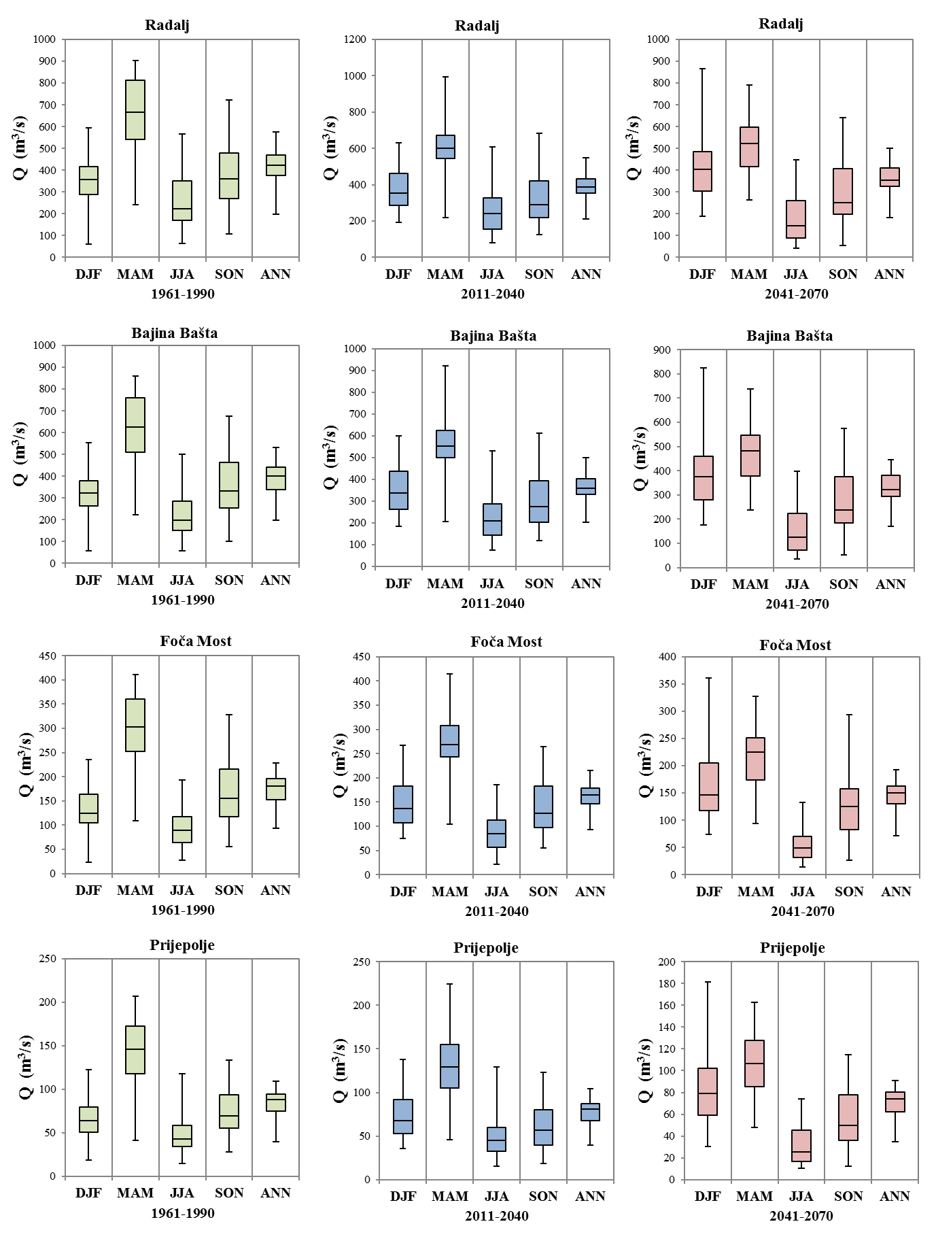
Figure 5-1: Long-term mean annual (ANN) and mean seasonal projections for analyzed hydrologic stations in accordance with the CM1 climate parameter seta – Part 1
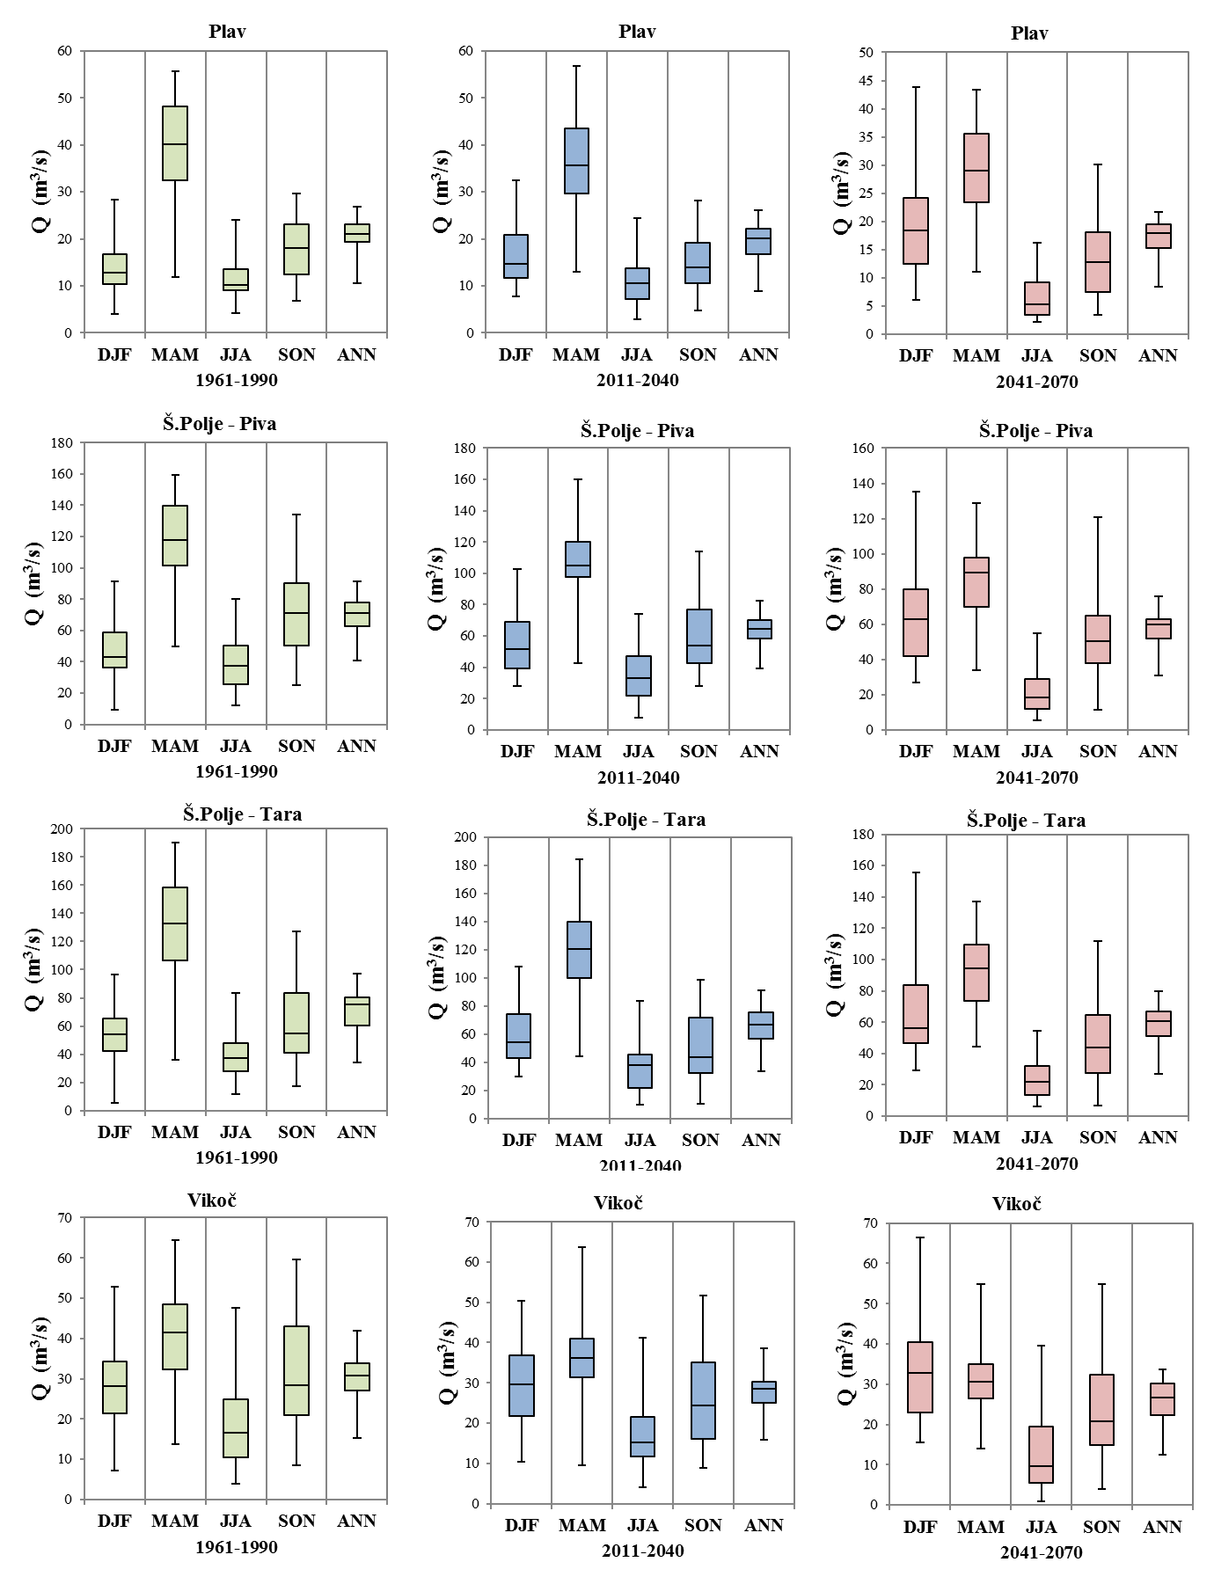
Figure 5-2: Long-term mean annual (ANN) and mean seasonal projections for analyzed hydrologic stations in accordance with the CM1 climate parameters set – Part 2
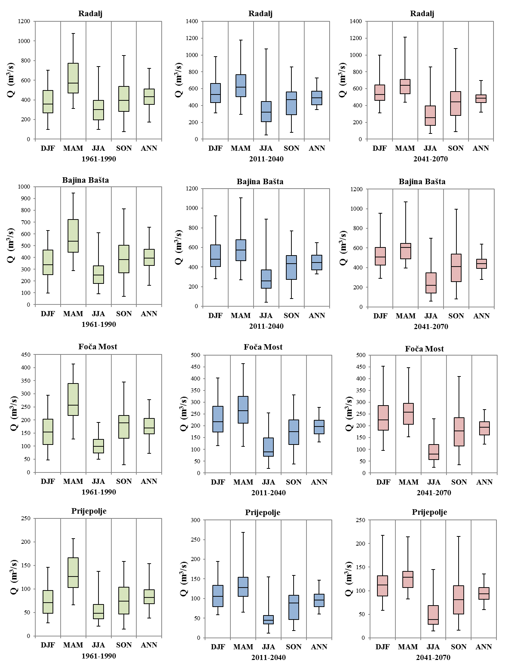
Figure 5-3: Long-term mean annual (ANN) and mean seasonal projections for analyzed hydrologic stations in accordance with the climate CM2 parameter set – Part 1
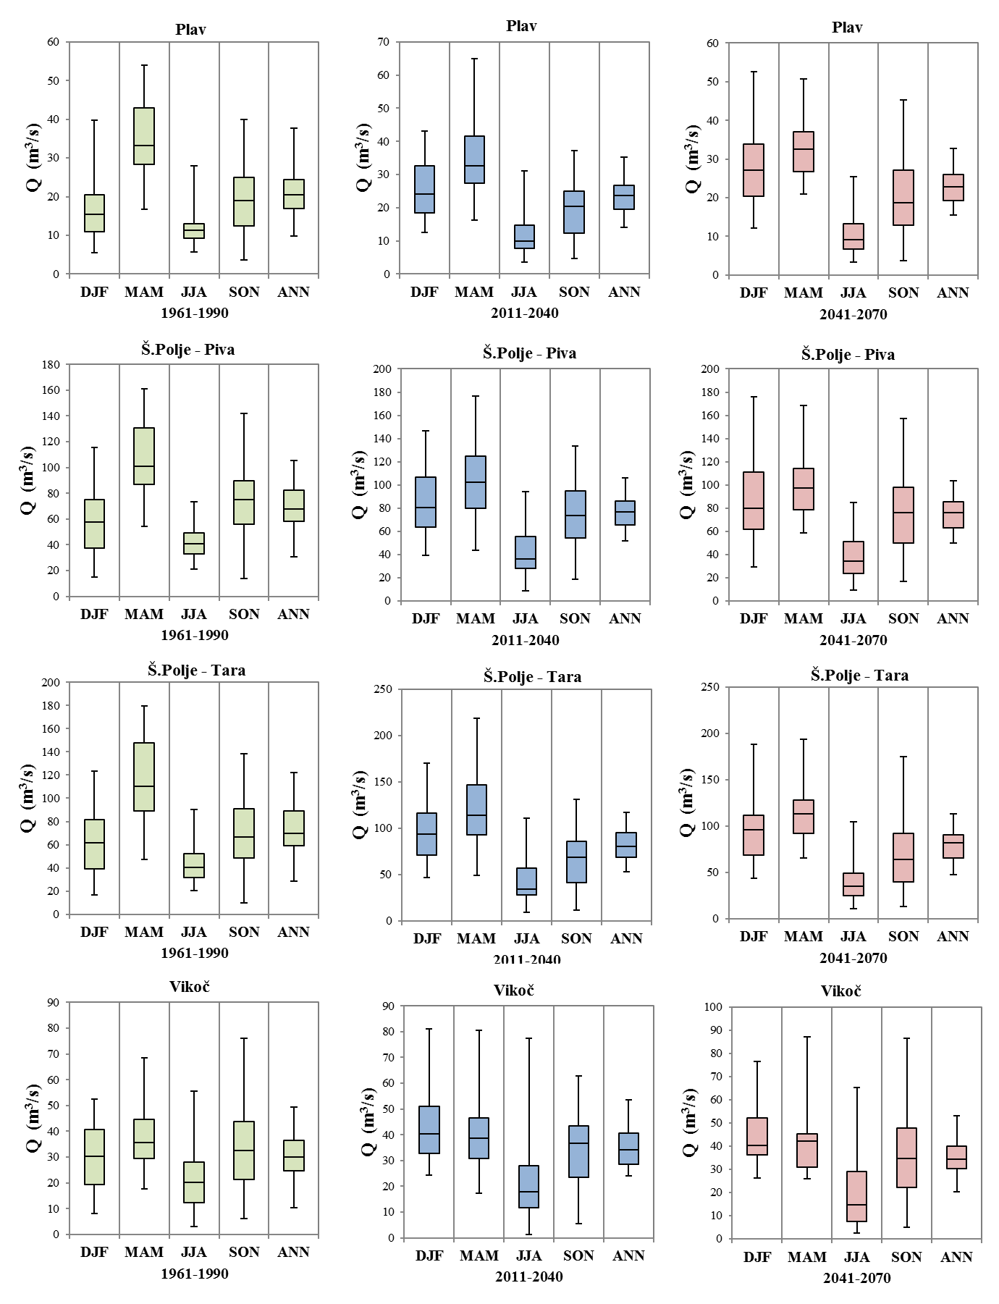
Figure 5-4: Long-term mean annual (ANN) and mean seasonal projections for analyzed hydrologic stations in accordance with the CM2 climate parameter set – Part 2

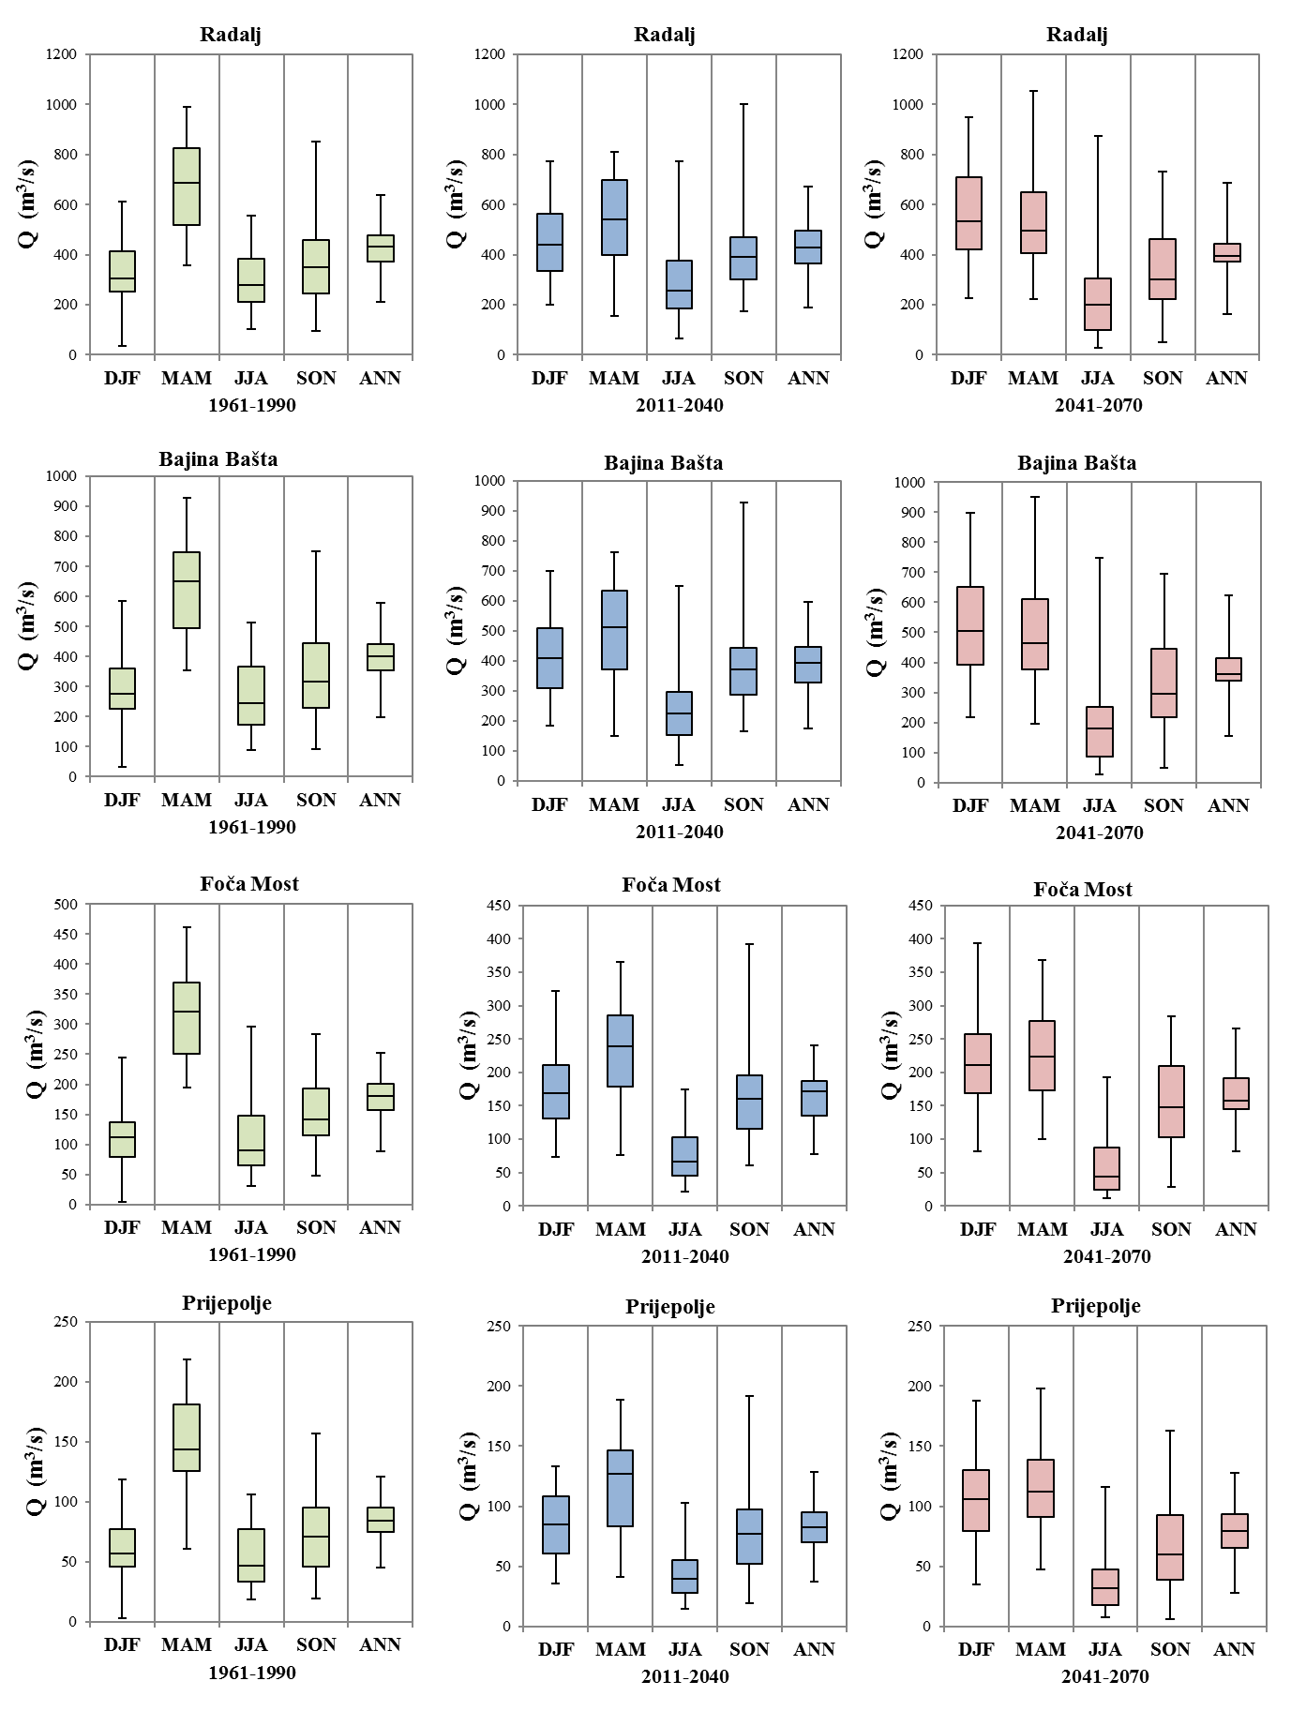
Figure 5-5: Long-term mean annual (ANN) and mean seasonal projections for analyzed hydrologic stations in accordance with the CM3 climate parameter set – Part 1
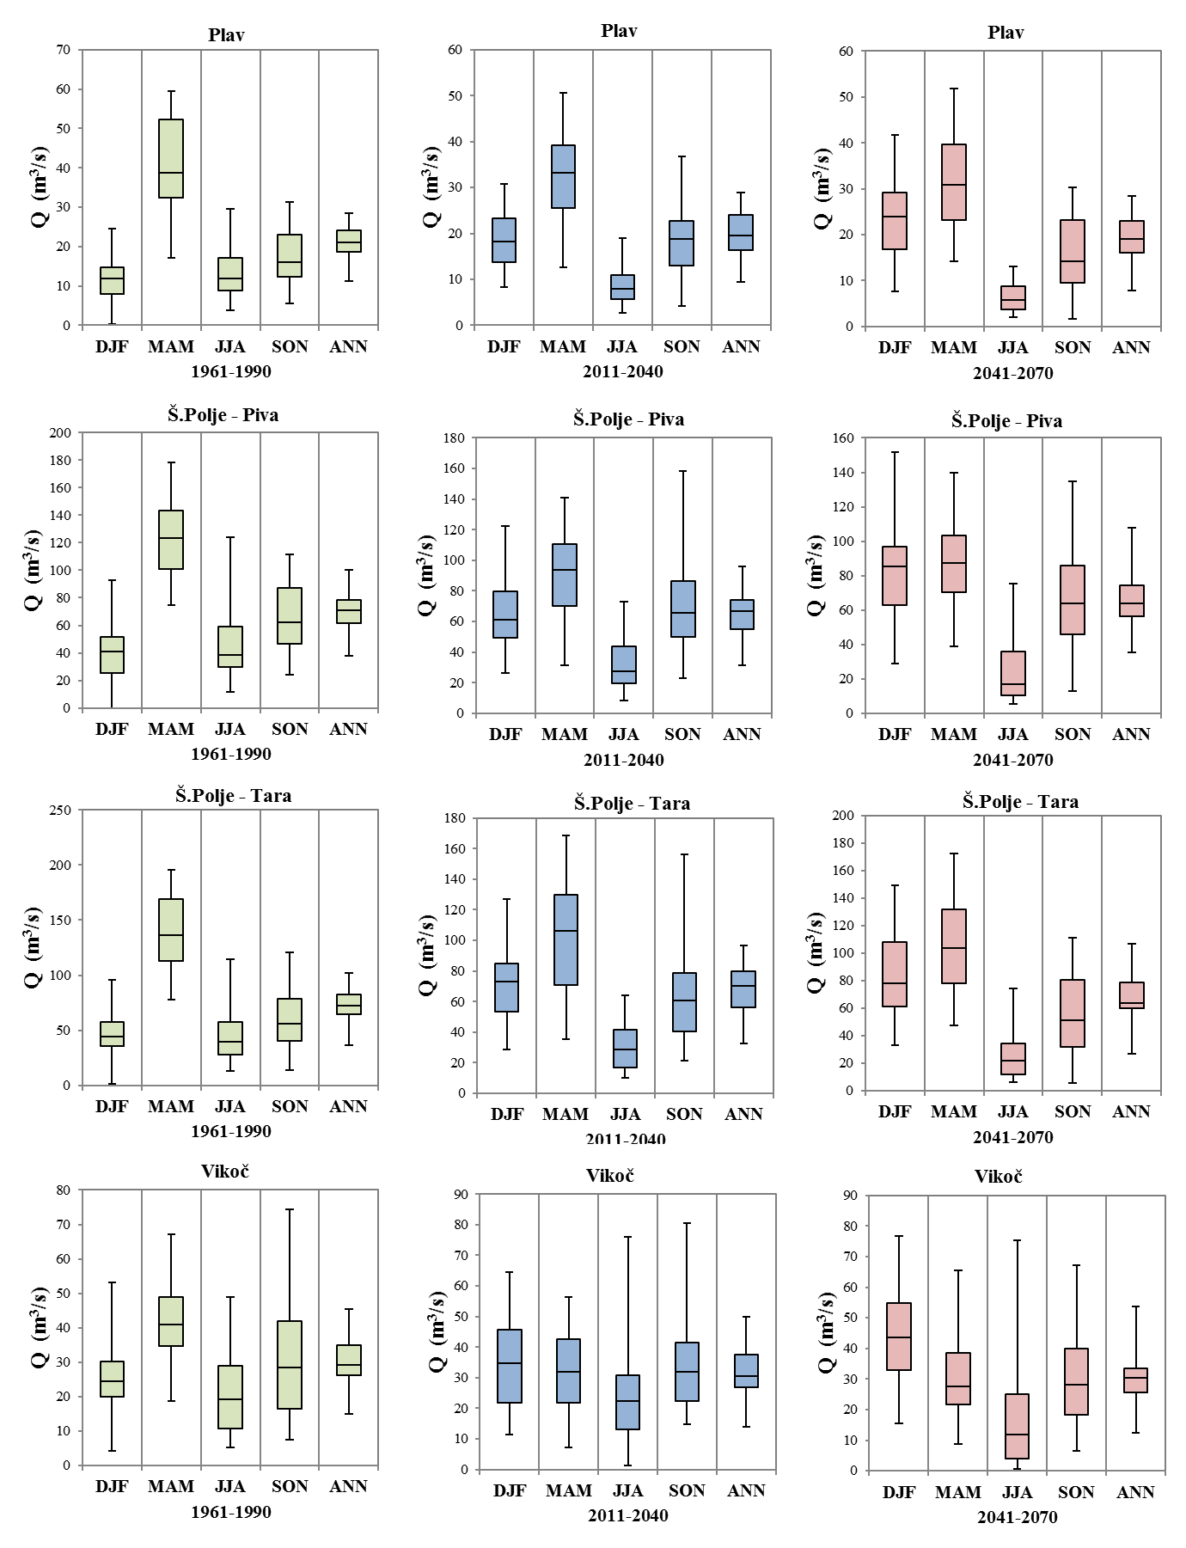
Figure 5-6: Long-term mean annual (ANN) and mean seasonal projections for analyzed hydrologic stations in accordance with the CM3 climate parameter set – Part 2
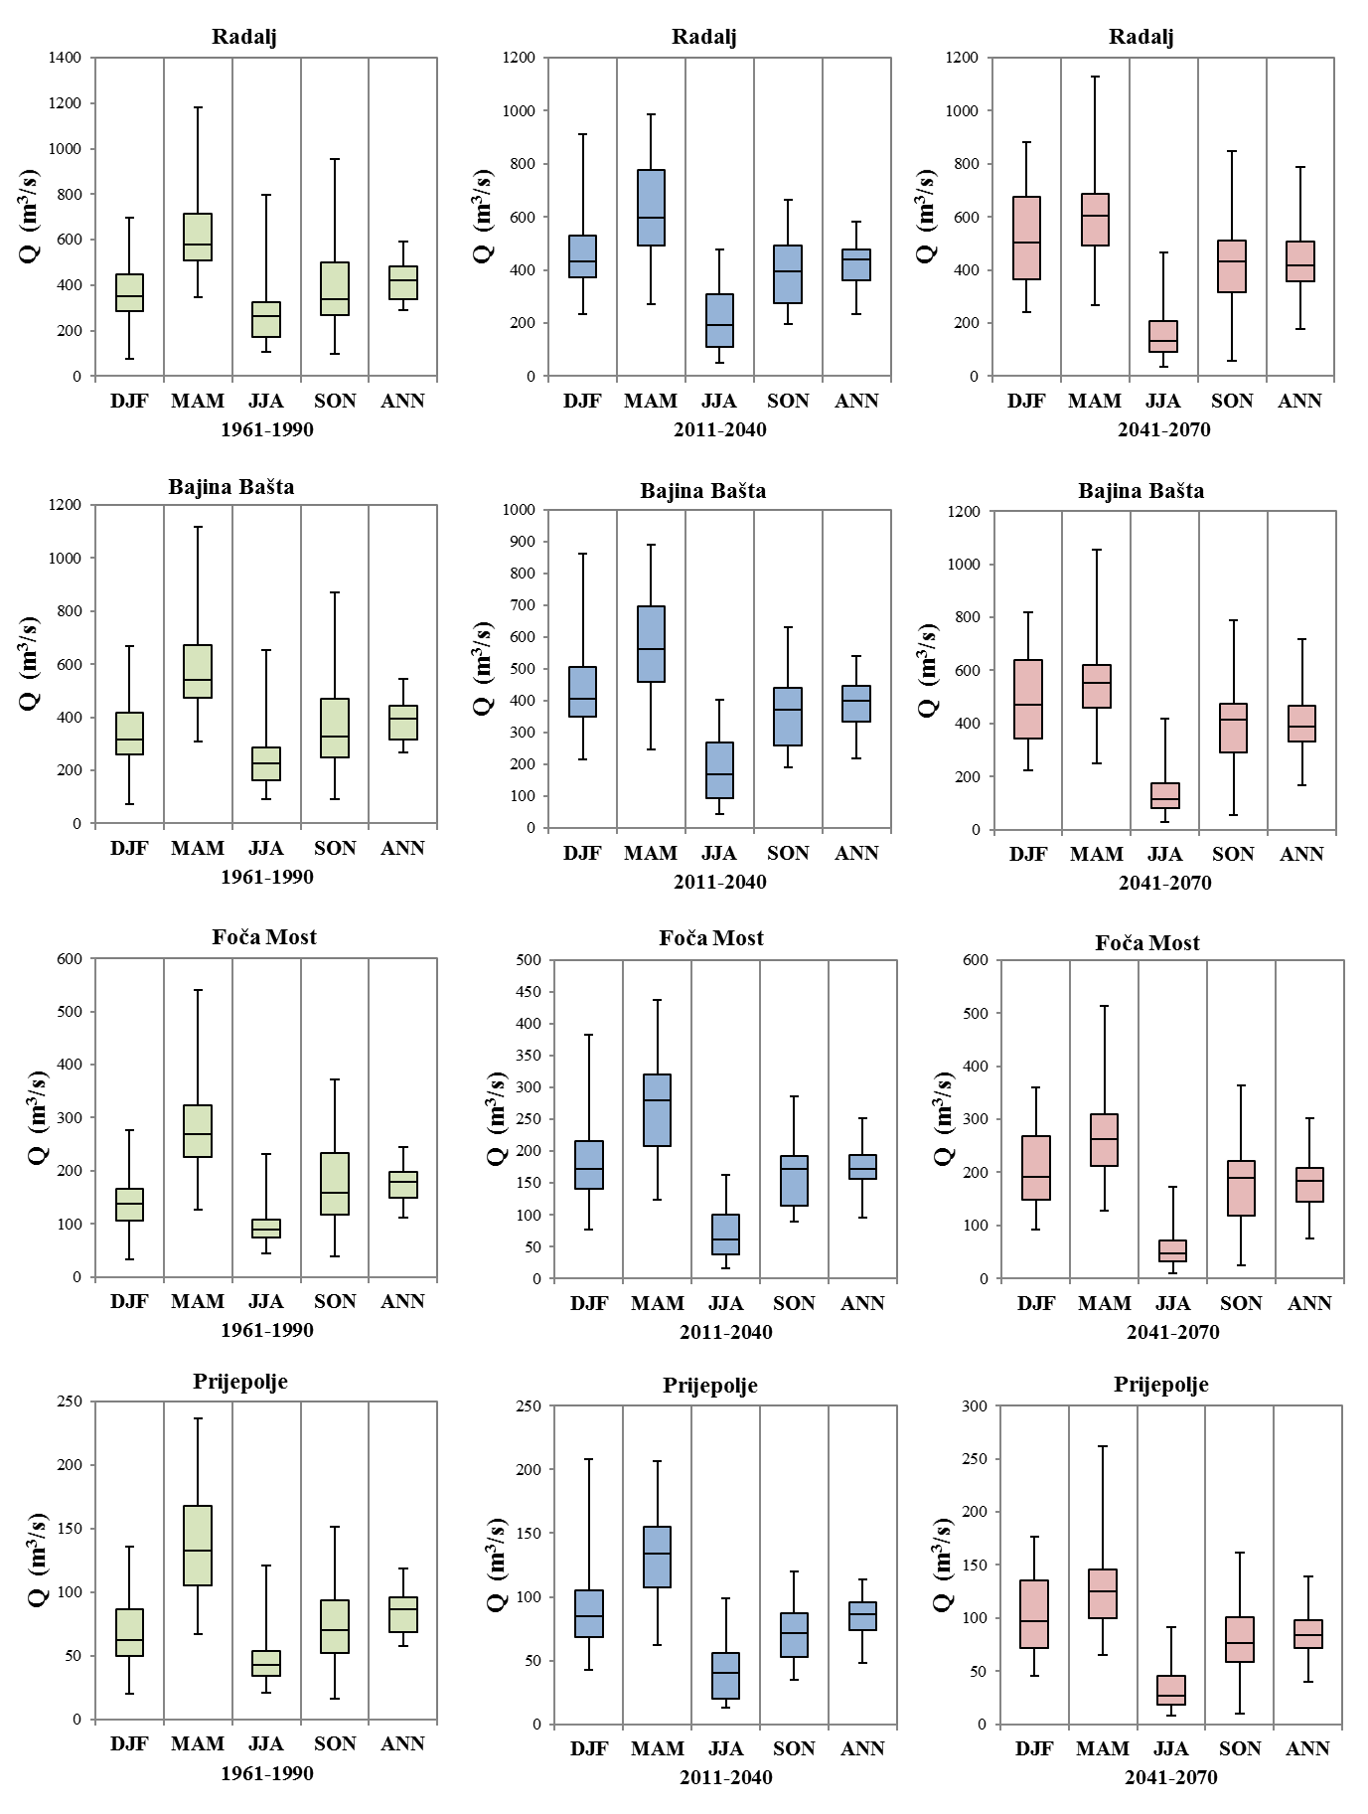

Figure 5-7: Long-term mean annual (ANN) and mean seasonal projections for analyzed hydrologic stations in accordance with the CM4 climate parameter set – Part 1

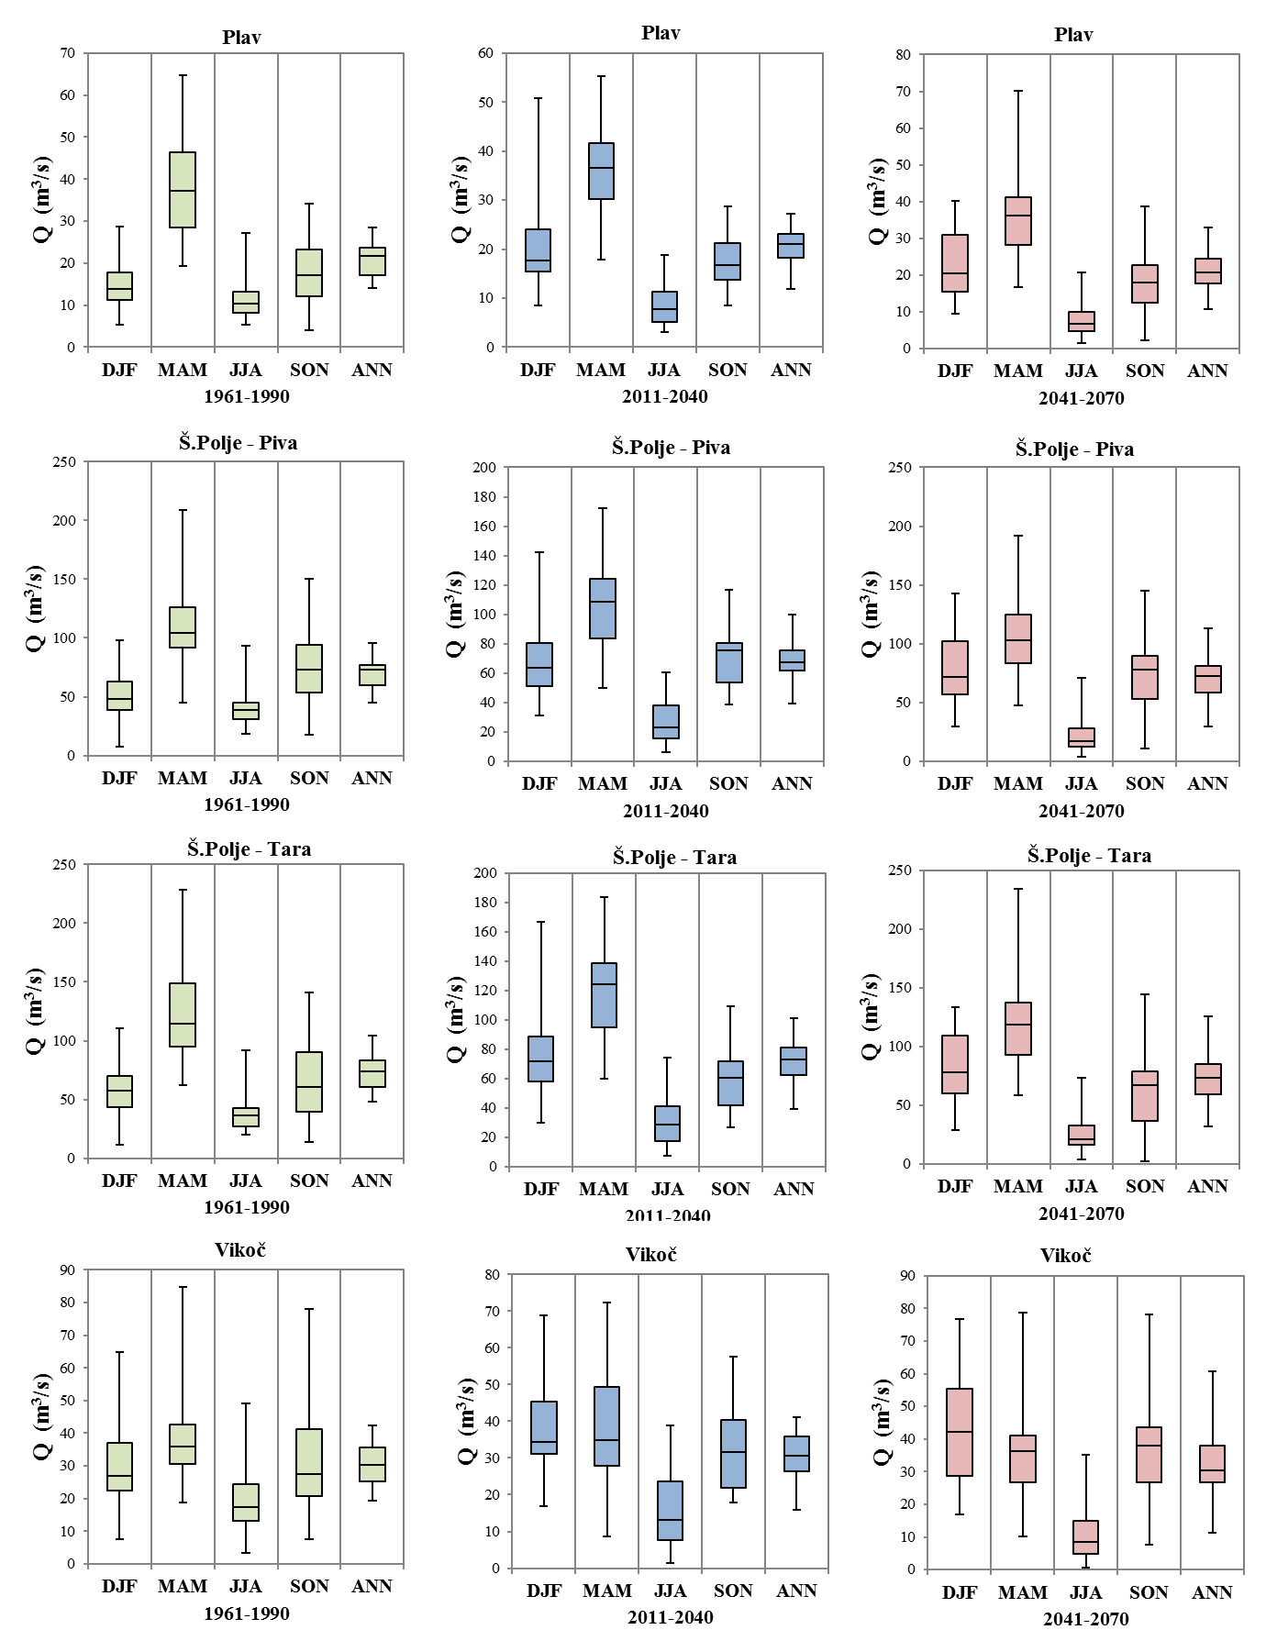

Figure 5-8: Long-term mean annual (ANN) and mean seasonal projections for analyzed hydrologic stations in accordance with the CM4 climate parameter set – Part 2

Figure 5-9: Long-term mean annual (ANN) and mean seasonal projections for analyzed hydrologic stations in accordance with the CM5 climate parameter set – Part 1

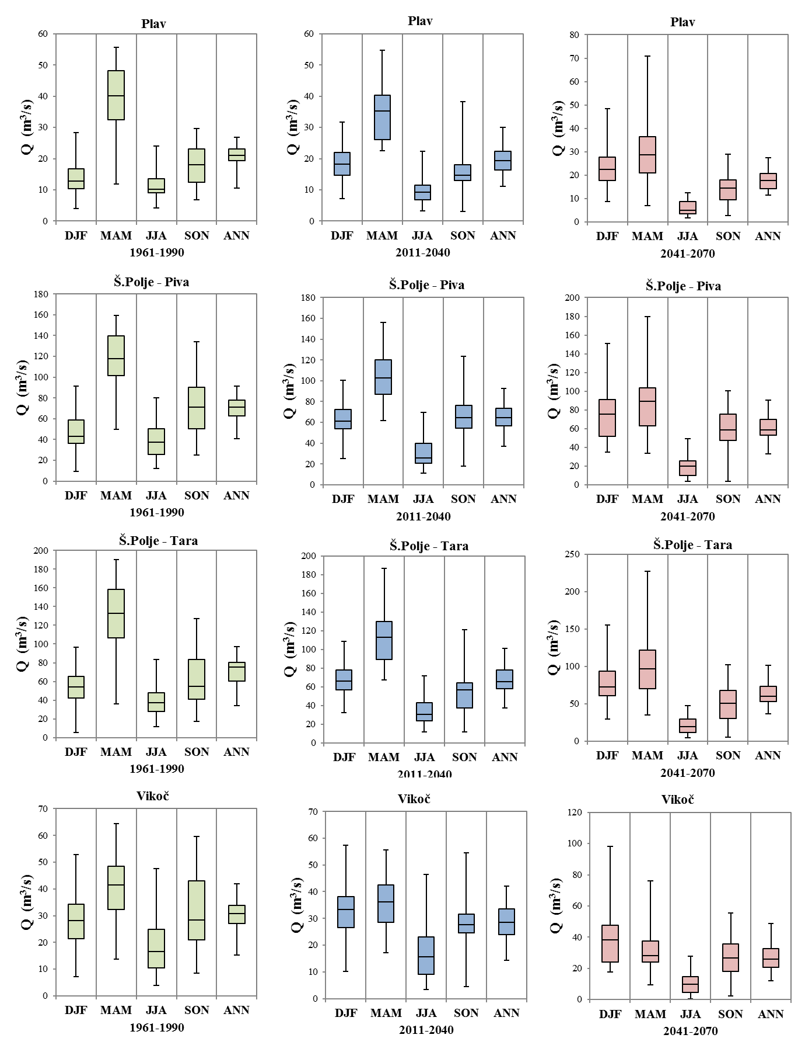
Figure 5-10: Long-term mean annual (ANN) and mean seasonal projections for analyzed hydrologic stations in accordance with the CM5 climate parameter set – Part 2
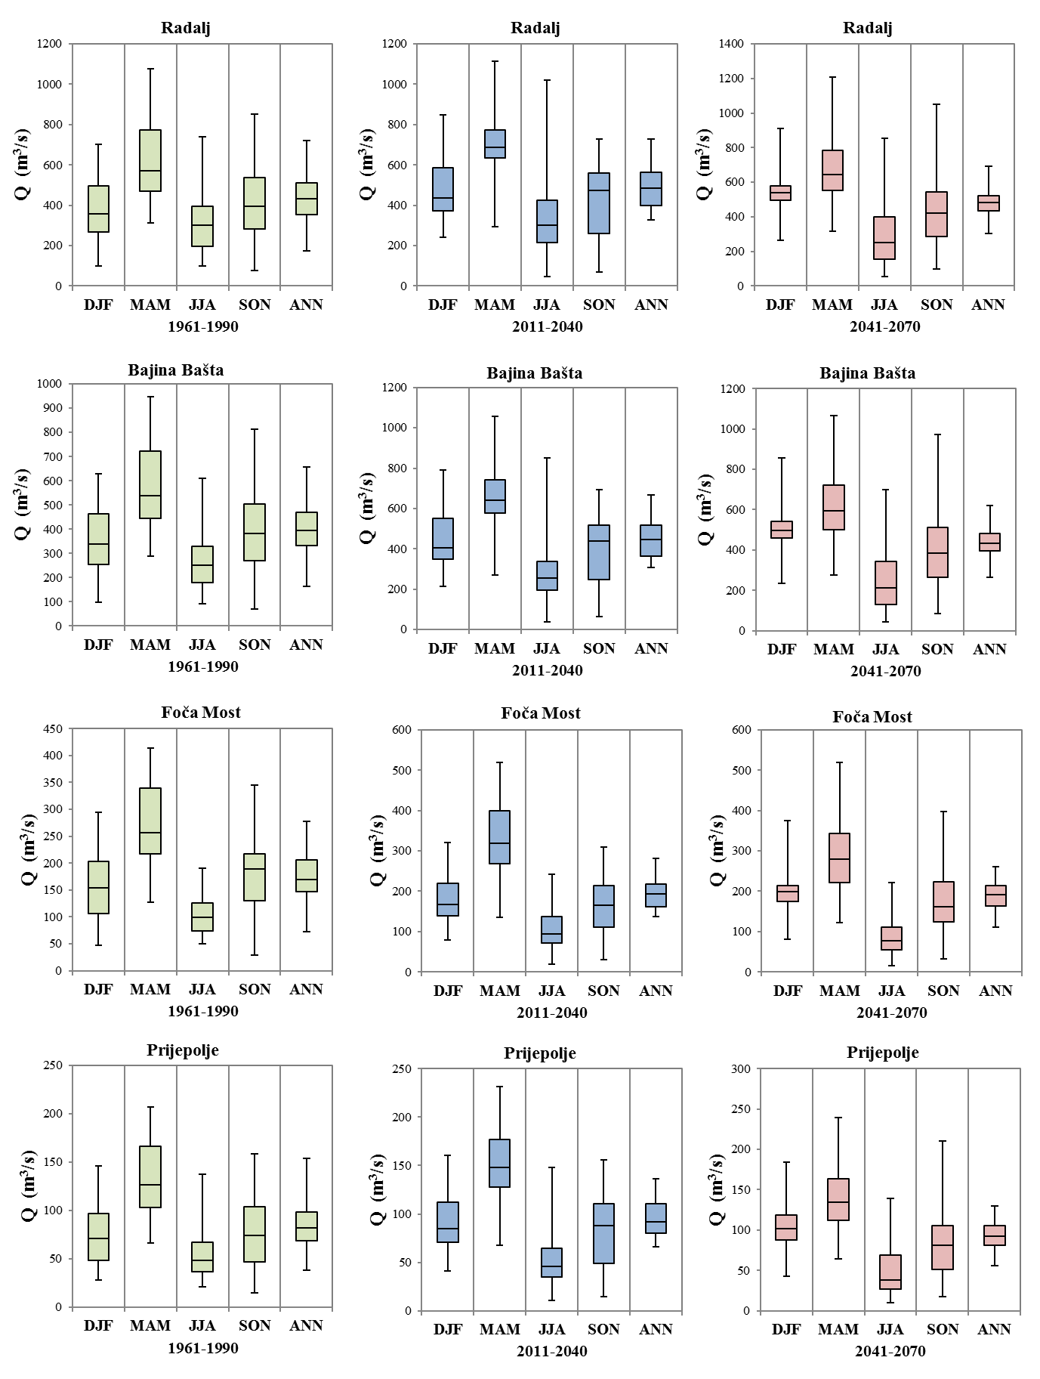

Figure 5-11: Long-term mean annual (ANN) and mean seasonal projections for analyzed hydrologic stations in accordance with the CM6 climate parameter set – Part 1
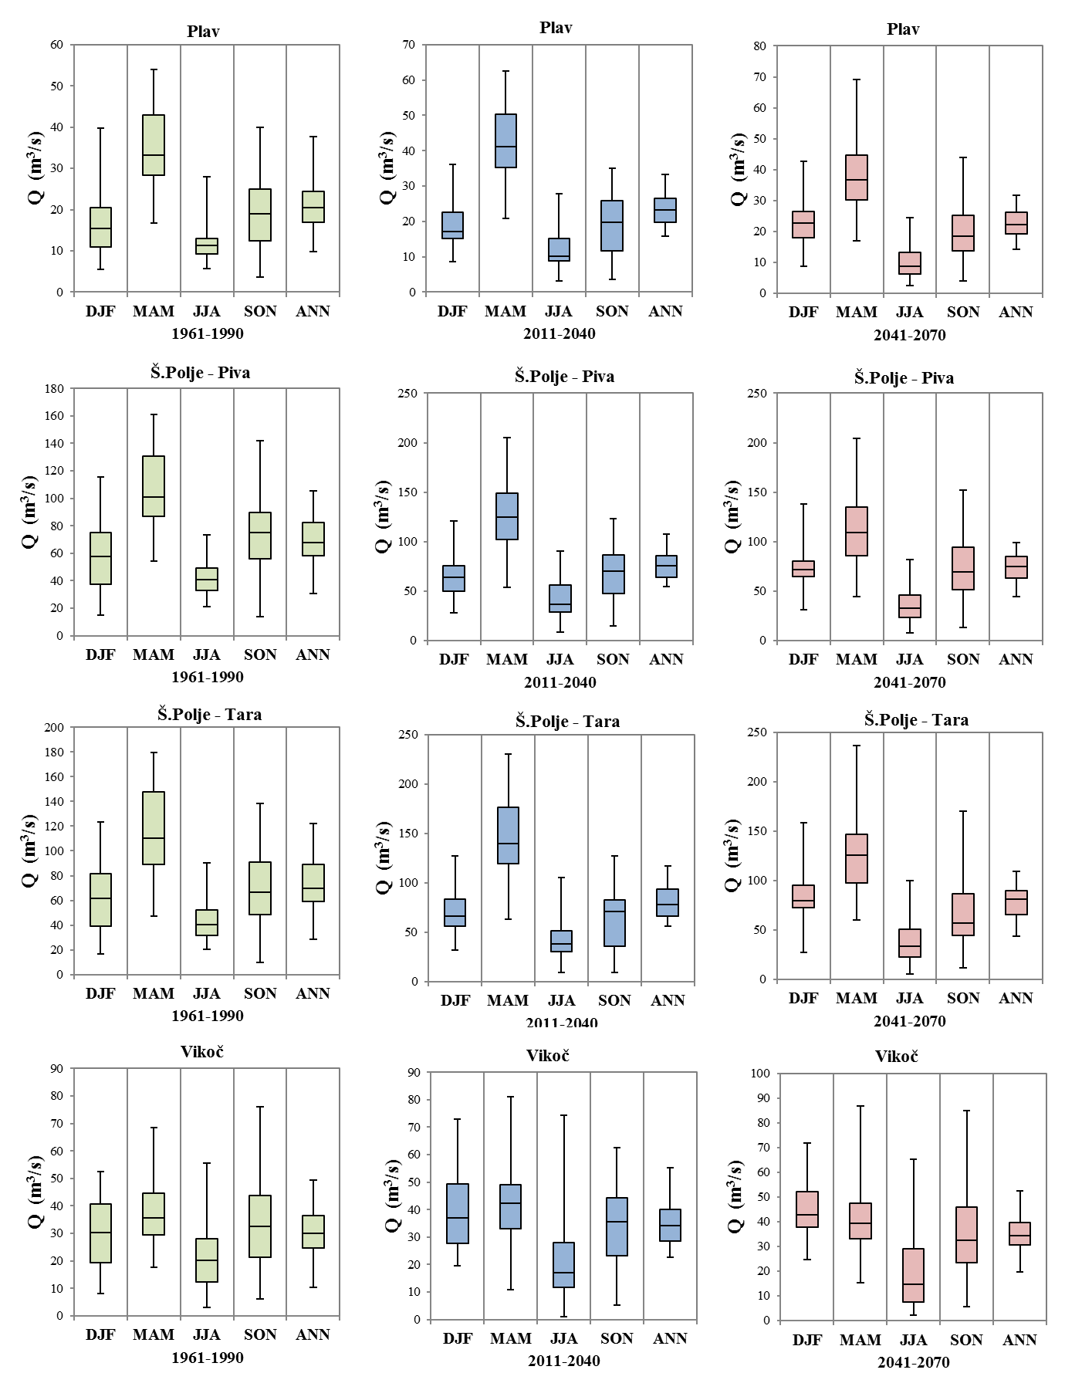
Figure 5-12: Long-term mean annual (ANN) and mean seasonal projections for analyzed hydrologic stations in accordance with the CM6 climate parameter set – Part 2

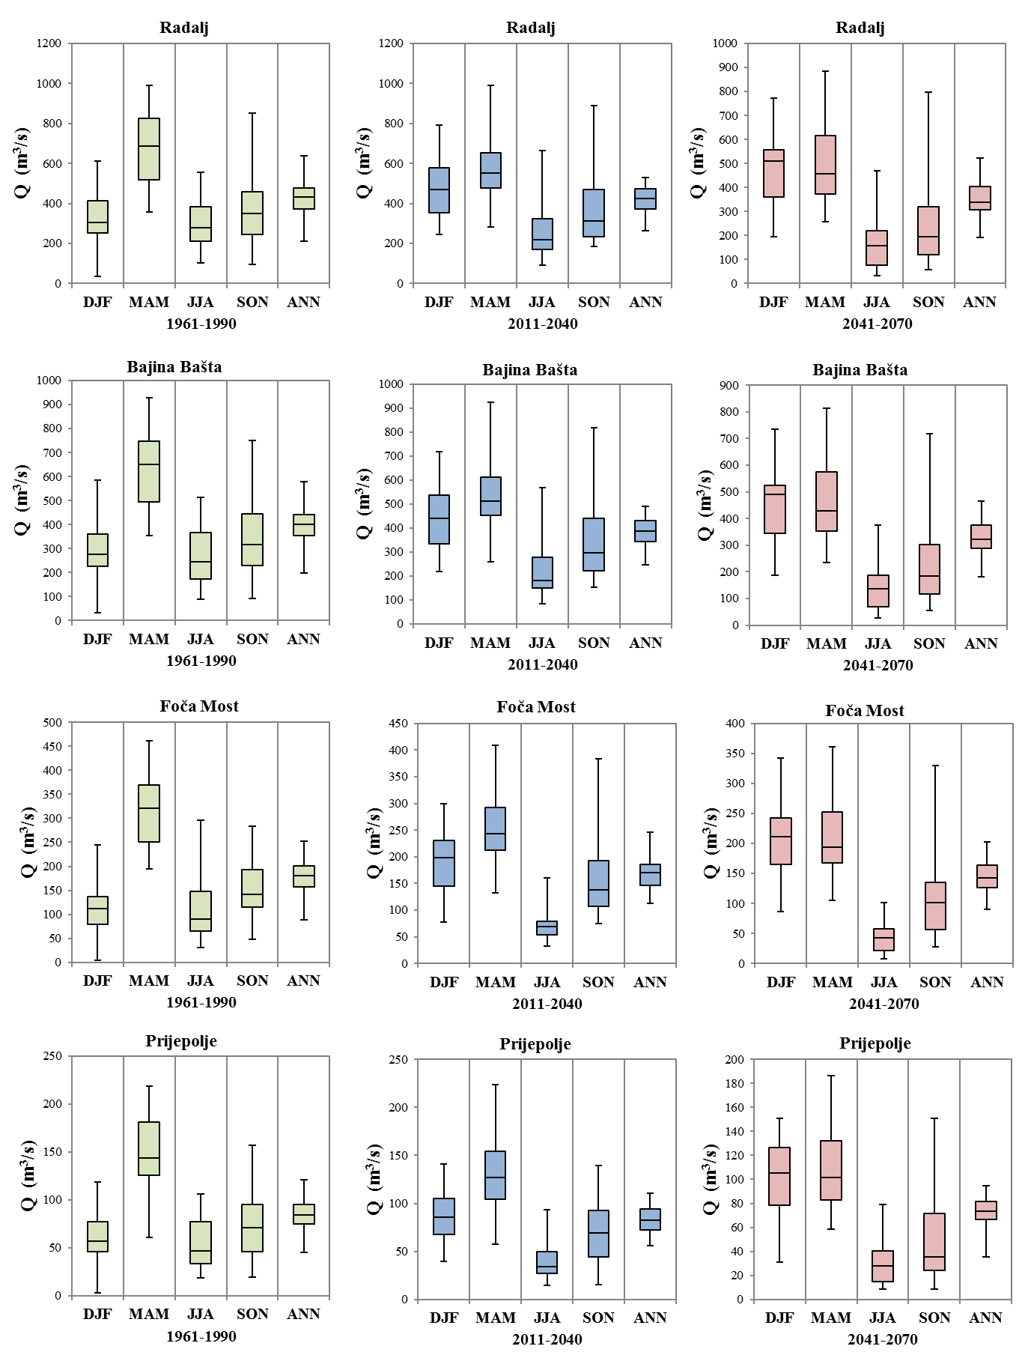
Figure 5-13: Long-term mean annual (ANN) and mean seasonal projections for analyzed hydrologic stations in accordance with the CM7 climate parameter set – Part 1
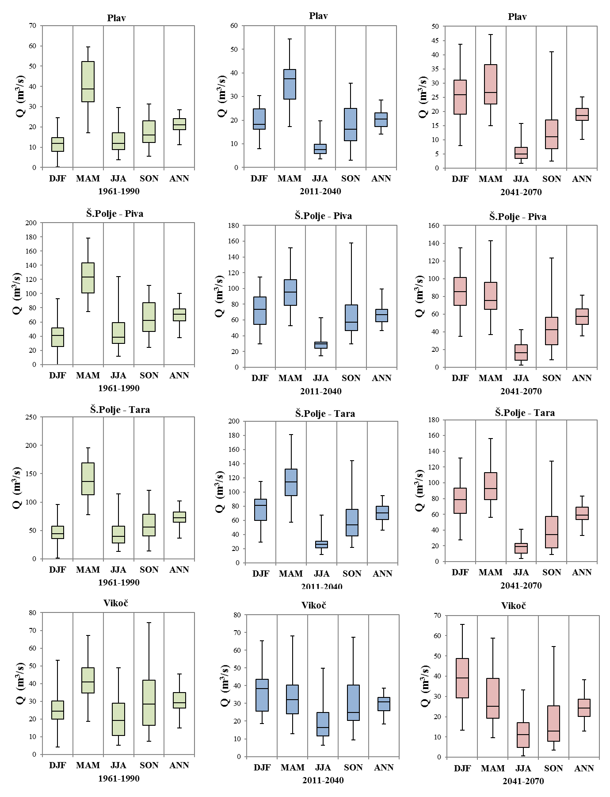
Figure 5-14: Long-term mean annual (ANN) and mean seasonal projections for analyzed hydrologic stations in accordance with the CM7 climate parameter set – Part 2
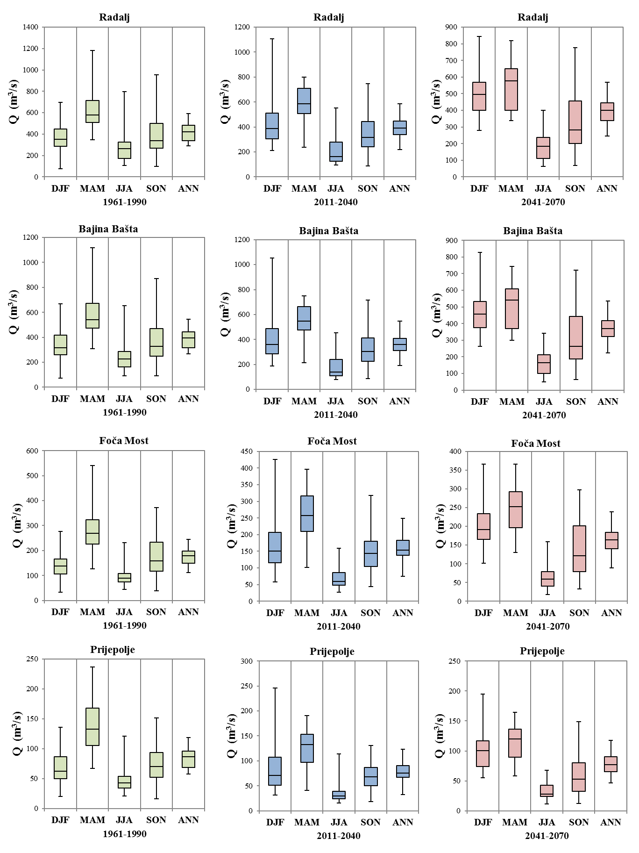
Figure 5-15: Long-term mean annual (ANN) and mean seasonal projections for analyzed hydrologic stations in accordance with the CM8 climate parameter set – Part 1
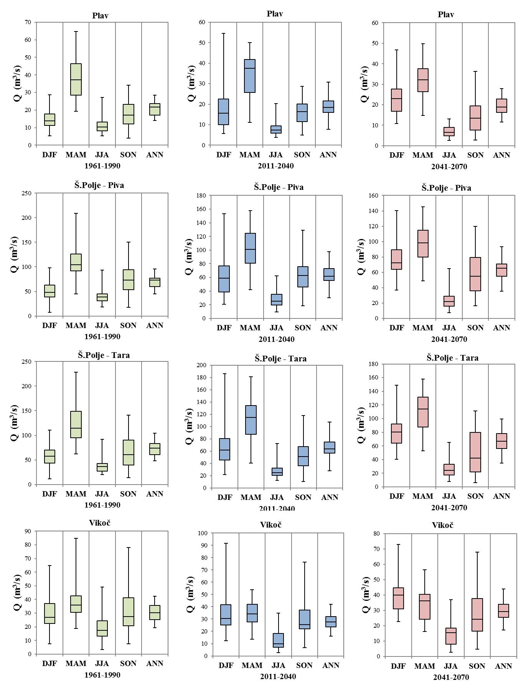

Figure 5-16: Long-term mean annual (ANN) and mean seasonal projections for analyzed hydrologic stations according to the CM8 climate parameter set – Part 2

Figure 5-17: Relative changes (Δ) of mean annual discharges (ANN) during the periods of near (from 2011 to 2040) and distant future (from 2041 to 2070) for analyzed hydrologic stations and used climate data sets (CM1 to CM8).
Figure 5-18: Relative changes (Δ) of mean proticaja in the course of winter season (DJF) during the periods of near (from 2011 to 2040) and distant future (from 2041 to 2070) for analyzed hydrologic stations and used climate data sets (CM1 to CM8).
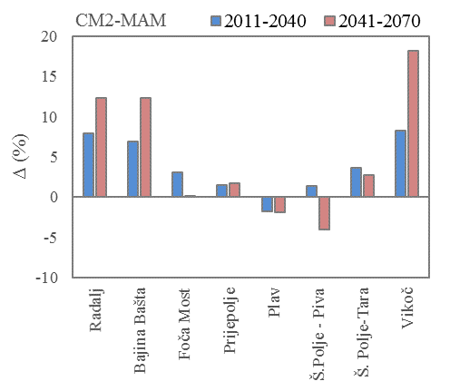
Figure 5-19: Relative changes (Δ) of mean discharges in the course of spring season (MAM) during the periods of near (from 2011 to 2040) and distant future (from 2041 to 2070) for analyzed hydrologic stations and used climate data sets (CM1 to CM8).
Figure 5-20: Relative changes (Δ) of mean discharges in the course of summer season (JJA) during the periods of near (from 2011 to 2040) and distant future (from 2041 to 2070) for analyzed hydrologic stations and used climate data sets (CM1 to CM8).
Figure 5-21: Relative changes (Δ) of mean proticaja in the course of autumn season (SON) during the periods of near (from 2011 to 2040) and distant future (from 2041 to 2070) for analyzed hydrologic stations and used climate data sets (CM1 to CM8).
Figure 5-22: Relative changes (Δ) of higher mean annual proticaja with exceedance probability of 10% during the periods of near (from 2011 to 2040) and distant future (from 2041 to 2070) for analyzed hydrologic stations and used climate data sets (CM1 to CM8).
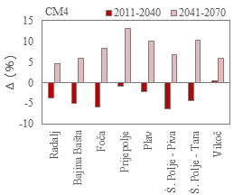
Figure 5-23: Relative changes (Δ) of lower mean annual discharges with exceedance probability of 90% during the periods of near (from 2011 to 2040) and distant future (from 2041 to 2070) for analyzed hydrologic stations and used climate data sets (CM1 to CM8).

Annex 5-2 Supporting Sub-chapter 5-3 Water resources system modelling
Table 5-10 Existing HPPs
 |  |  | Environmental Flow (m3/s)
 |  |  | Concession
Country | Planned HPP | River
RS-BiH | HPP "Visegrad" | Drina | 50
RS-BiH/S | HPP, "Bajina Basta" | Drina | 50
RS-BiH/S | HPP, "Zvornik" | Drina | 60
MNE | HPP, "Piva" | Piva | 25
MNE | HPP, "Otilovici" | Cehotina | 0.8
S | HPP, "Uvac "("Sjenica") | Uvac | 0
S | HPP, "Kokin Brod" | Uvac | 0
S | HPP, "Radoinja-Bistrica" | Uvac | 14
S | HPP, "Potpec" | Lim | 13.9

Figure 5-24 Planned HPPs :in red the values proposed for an harmonized EF over the DRB (- no data)

Annex 3-3 Supporting Sub-chapter 5.4 Flood risk assessment
Impact of climate change on flood flows of Lower Drina River
The impact of climate change on flood flows in the lower Drina Basin is estimated by considering change in flood flows at the Radalj hydrologic station, which is the only operational station in this part of the Drina River. The data on annual maximum flood flows of Drina at Radalj is available for the period 1950-2015, with few years missing from the record. The greatest flood flow of 5370 m3/s was recorded in 1968. Figure 1 shows the frequency distribution of the annual maximum floods at Radalj estimated from the full available record. The same figure also shows the frequency distribution of the annual maximum floods from the baseline period (1961-1990), which is estimated from 28 available annual maxima from this period (data from two years were missing). It must be noted that uncertainty stemming from frequency analysis of such a short record could be considerable. The baseline distribution has steeper upper tail than the full-record distribution; for example, the 100-year flood estimated from the full record is 5470 m3/s, while it is estimated at 6020 m3/s from the baseline period (which makes a difference of about 10%). Figure 1 also shows the 90% confidence interval for the general extreme value (GEV) distribution (shown as grey area in the figure). Flood frequency distribution from the baseline period is within the confidence interval so the difference between two distributions could be considered as the sampling error.
Figure 5-25. Flood frequency distribution of floods at Radalj for the baseline period compared to the distribution obtained from the complete record.

Figure 5-26. Flood frequency distributions for baseline period and two future periods under two climate scenarios (left graphs: RCP 4.5, right graphs: RCP 8.5).
In order to use the results of hydrologic simulations with climate scenarios (described in Chapter 5.2), it is necessary to verify the hydrologic model outputs against the observed floods for the baseline period. Two top graphs in Figure 5-26 provide the comparison of the frequency distributions of the observed and simulated floods for the baseline period according to hydrologic simulations with input from four climate models under climate scenarios RCP 4.5 (left graph) and RCP 8.5 (right graph). These graphs also show also the 90% confidence intervals for the distribution of the annual maximum floods from the complete record 1950-2015. Climate simulations under the two climate scenarios give the same results for the historical period 1961-1990, hence resulting in the same hydrologic simulations, and therefore the two graphs do not differ. The comparison for the baseline period shows that hydrologic simulations with input from all climate models except one (model 2) provide annual maximum floods within the given confidence interval. However, none of the models provide extreme floods as the greatest flood on the record, and the frequency distribution of the simulated annual maxima cannot yield the 100-yr flood close enough to the observed one (Table 5-2). Therefore, the frequency analysis of the simulated annual maxima from the 30-year baseline period cannot be considered reliable for quantifying the impact of climate change on the lower Drina flood flows.
Table 5-11. 100-year flood flows of Drina at Radalj hydrologic station – comparison of estimates based on the observed and simulated hydrology.
Annual maxima series | Period | Sample size | 100-yr flood (m3/s)
Observed | 1950-2015 | 62* | 5470
Observed | 1961-1990 | 28** | 6020
Simulated with climate model 1 | 1961-1990 | 29*** | 4508
Simulated with climate model 2 | 1961-1990 | 29*** | 5113
Simulated with climate model 3 | 1961-1990 | 29*** | 3919
Simulated with climate model 4 | 1961-1990 | 29*** | 5195
*Missing data: 1962, 1963, 2004, 2005
**Missing data: 1962, 1963
***Year 1961 (hydrologic model warm-up period) not included

However, Figure 5-2 can provide some indications on the future behaviour of the floods in the lower Drina. The middle and lower graphs in Figure 5-2 show the empirical distributions of floods at Radalj based on four climate models and according to two climate scenarios. The graphs also show the median distribution from the ensemble of climate models (blue lines). In climate change impact studies the ensemble median (or mean) results are considered more reliable than any of the individual result (IPCC, 2014). Therefore, based on the position of the ensemble median empirical flood distribution, it could be concluded that more frequent floods could occur in the near future (2011-2040), but their magnitude would not exceed the flood magnitudes already experienced during the historical period. Also, uncertainty inherent in the climate model ensemble is rather low as all models are producing very similar empirical distributions of annual maximum floods. The ensemble median distribution of floods for the distant future (2041-2070) under RCP 4.5 exhibits similar behaviour like in the near future, but the upper tail of the ensemble median distribution under RCP 8.5 exceeds the greatest observed flood. Also, the uncertainty from the individual models in the distant future is greater and some models produce flood values that significantly exceed the greatest observed flood.
Fitting standard theoretical distributions to the 30-year series of simulated annual maxima would not provide reliable estimates of 100-year floods and therefore was not performed in order to estimate impact of climate change on the Drina flood flows. Based on the results shown in Figure 2, the following could be concluded:
- The medium floods could become more frequent in both near and distant future. This means that the e.g. 10-year or 20-year floods would be expected more often, e.g. with frequencies of approximately 5 or 10 years respectively.
- The extreme floods exceeding the observed greatest floods could occur in the distant future with the same frequency as estimated from the historical record. The increase in the extreme floods magnitude is estimated at approximately 5% based on the ensemble median flood distribution.
It should be noted that the results of a comprehensive study of the climate change impacts on floods that was undertaken within the WATCAP project (World Bank, 2015) had shown a small increase of flood magnitudes for the lower Drina (7% for 2011-2040 and 14% for 2041-2070). As this study was specifically designed to assess the climate change impacts on floods, these results could be used with more confidence than the results stemming from hydrologic simulations within this project, which were designed to support the water management modelling and therefore were focused on maintaining water balance while not considering accuracy of flood flows.

Annex 4 – Supporting Multi-criteria analysis of development scenarios Chapter

Annex 4-1 Economic costs and benefits per scenarios
The following tables presents the details of economic costs and benefits.
Table 6-12: Economic costs and benefits Scenario 2 (EUR, Constant 2016 prices)
Table 6-13: Economic costs and benefits Scenario 3 (EUR, Constant 2016 prices)

Annex 4-2 Sensitivity analysis
The following tables constitutes the results of the sensitivity analysis of the Cost-benefit Analysis.
Table 6-14 Scenario 2
Discount rate | FNPV | ENPV | B/C | LCOE (EUR/kWh)
4% | -413,725,098 | 676,324,989 | 1.56 | 0.0425
5% | -492,812,537 | 534,515,009 | 1.47 | 0.0485
6% | -549,739,496 | 420,096,756 | 1.39 | 0.0549
7% | -590,771,838 | 326,086,667 | 1.32 | 0.0619
8% | -620,229,044 | 247,603,800 | 1.25 | 0.0692
9% | -641,132,888 | 181,177,212 | 1.19 | 0.0770
10% | -655,629,165 | 124,294,155 | 1.14 | 0.0852
11% | -665,264,700 | 75,102,225 | 1.09 | 0.0937
12% | -671,171,259 | 32,210,795 | 1.04 | 0.1026

Price of electricity | FNPV | FIRR | ENPV | EIRR | B/C
0.0292 | -620,229,044 | 1.30% | 181,177,212 | 12.85% | 1.19
0.0400 | -452,681,808 | 3.54% | 326,199,257 | 15.09% | 1.35
0.0500 | -297,882,868 | 5.24% | 460,186,899 | 16.86% | 1.49
0.0600 | -143,083,928 | 6.74% | 594,174,540 | 18.44% | 1.63
0.0700 | 11,715,012 | 8.10% | 728,162,182 | 19.87% | 1.77
0.0800 | 166,513,952 | 9.37% | 862,149,823 | 21.20% | 1.91
0.0900 | 321,312,891 | 10.57% | 996,137,464 | 22.45% | 2.06
0.1000 | 476,111,831 | 11.71% | 1,130,125,106 | 23.62% | 2.20
0.1100 | 630,910,771 | 12.80% | 1,264,112,747 | 24.73% | 2.34
0.1200 | 785,709,711 | 13.86% | 1,398,100,389 | 25.79% | 2.48
0.1300 | 940,508,651 | 14.88% | 1,532,088,030 | 26.80% | 2.62
0.1400 | 1,095,307,591 | 15.86% | 1,666,075,672 | 27.78% | 2.77
0.1500 | 1,250,106,531 | 16.82% | 1,800,063,313 | 28.72% | 2.91

Investment change | FNPV | FIRR | LCOE (EUR/kWh) | ENPV | EIRR | B/C
0% | -620,229,044 | 1.30% | 0.0692 | 181,177,212 | 12.85% | 1.19
-1% | -610,757,563 | 1.34% | 0.0686 | 189,802,669 | 13.07% | 1.20
-5% | -563,873,736 | 1.58% | 0.0656 | 224,304,498 | 13.99% | 1.25
-10% | -474,794,464 | 2.10% | 0.0598 | 267,431,784 | 15.24% | 1.31
1% | -629,700,524 | 1.25% | 0.0699 | 172,551,755 | 12.63% | 1.18
5% | -677,531,499 | 1.03% | 0.0729 | 138,049,926 | 11.80% | 1.14
10% | -777,976,548 | 0.60% | 0.0794 | 94,922,639 | 10.84% | 1.09

OM change | FNPV | FIRR | LCOE (EUR/kWh) | ENPV | EIRR | B/C
0% | -620,229,044 | 1.30% | 0.0692 | 181,177,212 | 12.85% | 1.19
-1% | -619,256,159 | 1.31% | 0.0692 | 181,988,426 | 12.86% | 1.19
-5% | -615,364,618 | 1.37% | 0.0689 | 185,233,283 | 12.92% | 1.20
-10% | -610,500,192 | 1.44% | 0.0686 | 189,289,353 | 12.99% | 1.20
1% | -621,201,929 | 1.28% | 0.0693 | 180,365,998 | 12.83% | 1.19
5% | -625,093,469 | 1.22% | 0.0696 | 177,121,141 | 12.78% | 1.19
10% | -629,957,895 | 1.14% | 0.0699 | 173,065,070 | 12.71% | 1.18

Table 6-15 Scenario 3
Discount rate | FNPV | ENPV | B/C | LCOE (EUR/kWh)
4% | -626,692,581 | 1,701,022,314 | 0.94 | 0.0409
5% | -764,370,324 | 1,363,589,150 | 0.89 | 0.0465
6% | -864,171,366 | 1,095,256,101 | 0.84 | 0.0526
7% | -936,662,583 | 878,073,912 | 0.80 | 0.0592
8% | -989,160,645 | 699,477,632 | 0.76 | 0.0661
9% | -1,026,809,206 | 550,529,730 | 0.72 | 0.0735
10% | -1,053,279,966 | 424,768,521 | 0.69 | 0.0812
11% | -1,071,233,952 | 317,445,084 | 0.66 | 0.0893
12% | -671,171,259 | 225,011,897 | 0.63 | 0.0977

Price of electricity | FNPV | FIRR | ENPV | EIRR | B/C
0.0292 | -989,160,645 | 1.51% | 550,529,730 | 15.23% | 1.35
0.0400 | -699,408,164 | 3.84% | 801,327,646 | 17.23% | 1.51
0.0500 | -431,702,304 | 5.58% | 1,033,042,907 | 18.86% | 1.66
0.0600 | -163,996,444 | 7.12% | 1,264,758,168 | 20.36% | 1.81
0.0700 | 103,709,416 | 8.53% | 1,496,473,429 | 21.74% | 1.96
0.0800 | 371,415,276 | 9.85% | 1,728,188,690 | 23.04% | 2.11
0.0900 | 639,121,136 | 11.09% | 1,959,903,951 | 24.26% | 2.26
0.1000 | 906,826,996 | 12.27% | 2,191,619,212 | 25.42% | 2.41
0.1100 | 1,174,532,856 | 13.41% | 2,423,334,473 | 26.53% | 2.56
0.1200 | 1,442,238,716 | 14.50% | 2,655,049,734 | 27.59% | 2.70
0.1300 | 1,709,944,576 | 15.56% | 2,886,764,995 | 28.61% | 2.85
0.1400 | 1,977,650,436 | 16.59% | 3,118,480,256 | 29.59% | 3.00
0.1500 | 2,245,356,296 | 17.59% | 3,350,195,517 | 30.53% | 3.15

Investment change | FNPV | FIRR | LCOE (EUR/kWh) | ENPV | EIRR | B/C
0% | -989,160,645 | 1.51% | 0.0661 | 550,529,730 | 15.23% | 1.35
-1% | -973,567,648 | 1.56% | 0.0655 | 564,685,581 | 15.45% | 1.37
-5% | -896,382,316 | 1.81% | 0.0627 | 621,308,985 | 16.37% | 1.42
-10% | -749,730,185 | 2.35% | 0.0572 | 692,088,239 | 17.61% | 1.49
1% | -1,004,753,641 | 1.46% | 0.0667 | 536,373,880 | 15.01% | 1.34
5% | -1,083,498,273 | 1.23% | 0.0696 | 479,750,476 | 14.19% | 1.29
10% | -1,248,862,000 | 0.79% | 0.0758 | 408,971,222 | 13.23% | 1.24

OM change | FNPV | FIRR | LCOE (EUR/kWh) | ENPV | EIRR | B/C
0% | -989,160,645 | 1.51% | 0.0661 | 550,529,730 | 15.23% | 1.35
-1% | -987,459,036 | 1.53% | 0.0661 | 551,950,274 | 15.24% | 1.35
-5% | -980,652,599 | 1.59% | 0.0658 | 557,632,450 | 15.29% | 1.36
-10% | -972,144,554 | 1.67% | 0.0655 | 564,735,170 | 15.35% | 1.37
1% | -990,862,254 | 1.50% | 0.0662 | 549,109,186 | 15.22% | 1.35
5% | -997,668,690 | 1.43% | 0.0664 | 543,427,011 | 15.17% | 1.35
10% | -1,006,176,735 | 1.35% | 0.0668 | 536,324,291 | 15.11% | 1.34

Annex 5 – Comments and responds

Name of Institution and Reviewer | Details of the Comments made in local | Comments in English | Response/ Action Taken In local | Response / Action Taken in English
MAEP – WD Dragana Milovanovic | Sliv Drine je obuhvaćen Planom upravljanja za sliv reke Save | Page 2-1, Par 2:  The EU WFD requires for the completion of a River Basin Management Plan (RBMP) which ideally must be reviewed on a six-yearly basis. The Drina River Basin (as a part of the Sava basin district) is no exception to this and the updating of the Basis (i.e. the project at hand) will enable the RBMP to be prepared and to be used as the start of a cyclical process that should be repeated every 6 years. | Konsultant je prilagodio tekst | The Consultant has amended the text accordingly
MAEP – WD Dragana Milovanovic | Treba dati komentar I za pritoke | Page 2-1, Par. 2.1  The other classification used in Serbia relates to the river quality and is in accordance with Serbian Regulation No. 50/2012 where the evaluation is done in a class system (classes I to V). According to the general group of parameters, pH and suspended solids, the Drina River belongs to Class I-IV and Class I-II, respectively, and tributaries?. | Kvalitet vode reke Drine i pritoka je detaljno obradjen u IWRM izvestaju (poglavlje 6). U cilju izbegavanja ponavljanja, IPF izvestaj u poglavlju 2 daje samo sazeti prikaz istog. Konsultant ce svakako u tekst dodati sazeti prikaz pritoka po klasama | Water Quality of Drina River and its tributaries has been elaborated in detail in IWRM Country Report (Chapter 6). In order to avoid repetition, IPF Report, Chapter 2 provides only a summary of the IWRM Chapter 6. However, the Consultant will amend the text with summary of the Class for the tributaries.
MAEP – WD Dragana Milovanovic | Obavezno navesti info o radu riblje staze na Zvorniku. Informmmacije su raspoložive I na internetu, dati sssu linkovi ekkkspertima | This middle part of the Drina River (Bajina Bašta dam to Zvornik Reservoir) is a high value section to be protected as the spawning areas for the Danube salmon. Drina downstream from Zvornik dam had cyprinid character even before the construction of reservoirs, and that characteristic remains today, having good ecological status. Moderate ecological status characterizes Lake Perućac and Lake Zvornik on the Drina River and the same stands for lakes on Lim and Uvac.  There is exising fish-pass at Zvornik dam. | Riblja staza na Zvorniku je integrisana u poglavlju koje se odnosi na biodiverzitet. Konsultant je u poglavlju 2 takodje dodao tekst o ribljoj stazi na Zvorniku | The fishladder of Zvornik dam is integrated in the biodiversity chapters. The Consultant has amended Chapter 2 adding the Zvornik fishladder.
MAEP – WD Dragana Milovanovic | Sliv Drine je obuhvaćen Planom upravljanja za sliv reke Save | Page 3-1, Par. 3.1  In line with WFD, RBMP are being prepared using 6 years planning cycle. In the EU MS, environmental goals are defined through three planning cycles: 2009-2015, 2016 -2021 and 2022 -2027. Similar planning principles are applied in non-EU MS countries. Taking the above into account, as well as the planning cycles and goals applied in the Sava RBMP (including Drina RDB), the planning horizon can be applied to period of 2016 -2021 as the short term and beyond 2021 as the long term. In line with the above, several goals can be defined, encompassing both short and long term perspective of DRB development | Konsultant je prilagodio tekst | The Consultant has amended the text accordingly
MAEP – WD Dragana Milovanovic | Nisu navedene investicije u oblasti vodosnabdevanja | Page 3-6, Par.  3.4 Review of all documentation regarding water related investments  3.4.1 Biodiversity investments  There are no water supply investments | Konsultant je dopunio izvestaj raspolozivim informacijama o investicijama u oblasti vodosnabdevanja. | The Consultant has added the information on the water supply investments based on the available information.
MAEP – WD Dragana Milovanovic | Nisu navedene lokacije nizvodno, veoma značajne za pitanja nanosa | Page 3-38, Par. 3.12.3  Effects on gravel extraction  According to local development strategy of the Municipality of Foca-Ustikolina there are three sites on the Drina River for the sand and gravel extraction. It is possible that some municipalities use materials from the Drina River (sand and gravel extraction) and it should be investigated since the construction of HPPs could have impact on it and consequently on local economy. At this level of the analysis, no data will permit to evaluate which of the HPP projects can have a high impact of gravel extraction.  Dowstream??? | Konsultant je dopunio izvestaj, navodima o lokacijama za eksploataciju sljunka nizvodno na osnovu prikupljenih i raspolozivih informacija | The Consultant has added the main gravel extractions in the dowstream part of the Drina based on the available information collected.
MAEP – WD Dragana Milovanovic | Previše teorije I metodologija. Ovo nije udžbenik | Page 4-1 Water management development options  4.1 Introduction  Too much theory and metodologies!!! | Konsultant ne moze da da odgovarajuci odgovor na komentar | The Consultant cannot provide appropriate feedback on the comment
MAEP – WD Dragana Milovanovic | Ne treba staviti protect against wastewater u tačku protect against flood waters, kvalitet je obuhvaćen u prrethodnoj tačci | Page 4-1:  4 Water management development options  4.1 Introduction  Protect against flood waters, wastewater, and other detrimental events and  WATER QUALITY IS WITHIN  Protect water quality | Konsultant je uskladio skracenice | The Consultant has aligned abbreviations
MAEP – WD Dragana Milovanovic | Nisu u skladu skraćenice I opisi u tekstu I na slici. Previše je teoretski data skica, dalego od aktuelnog načina dimenzionisanja | Page 4-3:  Figure 4 1 Reservoir management principles  The abbreviations in the figure are as follows:  Abbreviations are not as on figure 4 1 | Konsultant ce prilagoditi tekst | The Consultant will amend the text accordingly
MAEP – WD Dragana Milovanovic | Potpuno netačan stav. Ne može se sabirati prisečan proticaj na reci duž toka I sa pritokama. | Page 4-6  The total possible average annual flow that could be controlled within the catchment area with reservoirs is about 3663.5m3/s . The total reservoir useful storage in the basin is about 656 million m3, which corresponds to an overall regulation coefficient of 0.0057 or in other words an overall 0.57 % of the average annual inflow can be controlled by these reservoirs . Given that at this moment it is not possible to reliably predict the development scenario of climate change, presented analyse is based on “present” hydrology data. The reservoir total-useful volumes are mostly limited and not provide conditions for significant regulation. Due that fact, possible changes of average annual inflow induced by climate changes will not cause significant changes in obtained values of regulation coefficients  How? Did you sum up? You can’t summarize flow on the same river.  Average flow is cca 400 m3/s!  You have to check coefficient! | Konsultant je zamenio procenu “ukupnog regulatornog koeficijenta” sa iyracunavanjem regulatornog koeficijenta za svaku pojedinacnu akumulaciju. Izvestaj je izmenjen u skladu sa time. | Tha Consultant has replaced estimation of “overall regulation coefficient” with the calculation of regulation coefficient for particular reservoir. Report has been amended accordingly
MAEP – WD Dragana Milovanovic | Neophodan je kratak prikaz procedure I eventualni problemi, tek tada se može dati predlog | Page 4-8  Construction permits  The Government should consider a more restrictive policy regarding the location of housing and the procedure for issuing construction permits in order to avoid locating houses in areas prone to flooding without appropriate flood protection. It is necessary to amend and simplify procedures for granting spatial and other permits for HPP construction.  Short description of procedure is needed. | Konsultant je prilagodio i dopunio tekst | The Consultant has amended the text accordingly
MAEP – WD Dragana Milovanovic | Neophodno je dati kratak prikaz projekta FFWS | Page 4-10  Strengthening hydro-meteorological monitoring and early warning systems  Properly operating hydro-meteorological and the early warning systems are an important tool of flood management and is a requirement of the FD and, at the same time, are a pre-requisite of the assessment of flood risks and hazards within the implementation process. During the course of development of the systems, a complex approach is required that covers the areas of infrastructure, software, modelling tools and human capacity building.  Short description of ongoing Sava FFWS project | Konsultant je dopunio tekst kratkim prikazom projekta FFWS | The Consultant has amended the text and added short description of ongoing Sava FFWS project
MAEP – WD Dragana Milovanovic | Smatram d nij dobr izraz upotrebljn,. Ne realzu se svi pojek koceijma | Page 4-11  Harmonization and strengthening of concession authorisations  Cooperation between the riparian countries is necessary to harmonize the HPPs managements. It includes a common strengthening of the concession conditions for authorization of dam constructions such as (see chapter 3.10):  Permitting is better than concession authorisations | Konsultant je prilagodio tekst | The Consultant has amended the text accordingly
RHMS of Serbia, Samir Ćatović | Komentari se odnose na poglavlje 5.6, tacka 5.6.1,  Aktuelni status razmene podataka u pogledu upravljanja hidoelektranama  Komentar:  Ne postoji pristup portalu “Drina” HIS za RHMZ Srbije. | 5.6 Review needs and options for cooperation,  5.6.1 Data exchange  Current status of data exchange in management of hydropower plants  The application of the "Drina" HIS has significantly increased the level of reliability of data over which EPS disposes, and these data are now more easily accessible to RHMS  of Serbia and "Waters of Serbia" PWMC.  Comment:  “Drina” HIS is not accessible for RHMS of Serbia – there is no accsses to this portal. | Prema informacijama kojima Konsultant raspolaže, originalnim zadatkom za razvoj HIS "Drina" je bilo predviđeno da on pruža usluge razmene podataka i RHMZ-u. Prema istim izvorima, ni u današnjoj fazi razvoja HIS-a ne postoje tehničke prepreke tome da mu RHMZ pristupa u skladu sa svojim potrebama. Pristup portalu HIS „Drina“ je dozvoljen samo korisnicima sa odgovarajućim korisničkim nalogom, što je moguće obezbediti za osoblje RHMZ Srbije.  Konsultant je prilagodio tekst u skladu sa gore navedenim. | According to the information available to the Consultant, in the original Terms of Reference for the development of the "Drina" HIS it was envisaged that it should also provide the data exchange services to RHMS. According to the same sources, at the present stage of HIS development there are no technical obstacles to RHMS's access to it in accordance with its needs. The access to the "Drina" HIS portal is allowed only to the users having a proper user account and such account can be created for the RHMS staff.  The Consultant has amended the text in accordance with the above statement.
RHMS of Serbia, Samir Ćatović | Zaključci  Komentar:  Na portalu SavaHIS, vremenska diskretizacija raspoloživih podataka je 1 h za vodostaj, protok vode i temperaturu vode (na lokacijama sa automatskim stanicama i senzorom). Takodje, tokom implementacije projekta SavaFFWS – sistem prognoze i upozorenja na poplave za sliv reke Save (pocetak projekta Jun 2016 - kraj projekta je planiran za Avgust 2017. godine), podaci o padavunama ce takodje biti sa vremenskom diskterizacijon od 1h. | Conclusions  Data exchange time schedule is not at the level necessary for actual operations. Data is most often exchanged daily. This data exchange frequency can prove insufficient, particularly in critical situations. Consultant's opinion is that in this area exists room for significant improvement.  Comment:  On SavaHIS portal, data frequency is already 1 hour for water level, river flow and water temperature (where automatic stations and sensors exists). Also, during implementation of SavaFFWS project - Flood forecasting and warning system for the Sava River Basin (start of project Jun 2016 - end of project is planned in August 2017), precipitation data would also be with 1 hour frequency. | Konsultant će prilagoditi tekst.  Konsultantu je poznato u SavaHIS većina podataka već razmenjuje na tom nivou, dok će za padavine to biti moguće nakon završetka tog projekta (koji se završava nakon završetka WBIF projekta).  Cilj teksta je bio da se istakne da je potrebno postići da se razmena podataka odvija sa vremenskim korakom od 1h i u tom smislu Konsultant daje preporuku svim akterima koji učestvuju u prikupljanju podataka da ulože napor da se održi taj vremenski korak. | Consultant will amend the text.  Consultant is aware that the majority of data in the SavaHIS is already being exchanged with that time step and that the same will hold true for the precipitation after the completion of that project (which should be completed after the completion of the WBIF project).  The objective of the text was to emphasize that is necessary to achieve data exhange with the 1-hour time step; to that purpose the Consultant recommends that all participants in the data collection process should invest an effort in maintenance of that goal, i.e. time step.

For Brodarevo I, the site holds important populations of stenoendemic species Campanila secundiflora (endemic to Lim canyon and smaller canyons of it's tributaries, species of European conservation concern), and is likely to hold several other endemic, such as Alyssum montanum, Campanula patula, Lilium martagon, Edraianthus jugoslavicus (59 Balkan endemic species are present in the vicinity), and strictly protected plant species. Regarding the habitat, the site is an outstanding example of several habitat types, such as sparsely vegetated gravel banks, thermophile and supra-Mediterranean poly-dominant and oak forests, riparian willow formations... In addition, if the reservoir will be constructed, an additional degradation of habitats will occur as the European route E 763 will have to be moved further up at several localities. Therefore even if the magnitude of impact is in between medium and high negative, it was decided to score the overall impact as “High negative” due to this issue of endemic species and due to the cumulative effect.
For the reservoirs Drina I-III, Drina II and Drina III are within the borders of a planned protected area Nature Park Sava-Drina, and Drina III is partially within the borders of the planned Habitat management site Rača-Bijeljina. Additionally, the forests along the Drina River (Drina II, Drina III) are mostly composed of Willow and Poplar species and habitats that they form are unique for the region. In addition, for Habitat Directive of the EU, there are of community interest and their conservation is largely insufficient. About 90% of those habitats are situated within the planned reservoir developments. If only the Drina I reservoir would be constructed, the impact analysis could conclude to an overall impact as medium negative for Drina I only but since the 3 will be constructed, due to the cumulative impact, just about anything natural that is left along the Drina River will be destroyed for decades to come with destruction of very high value species and habitats. For this reason, even if the magnitude of the impact is in between medium and high negative, the team evaluates as “High negative” the overall impact due to the cumulative effect.

